**Unit 3 Commonly Used Software**

Software is used to refer to the set of instructions given to a computer to perform certain tasks. The games that we play and the programs that we use on the computer are all software. We will discuss four main software in this unit which are MS Paint, Typing Tutor, MS Word and Media Player.

**Learning Objectives**

After completing this unit, students will be able to

* Recognize MS Paint window
* Get familiar with menu bar, tool box and color box
* Draw freehand shapes with the pencil
* Use pen, shapes, spray, brush and other various tools to draw and color different shapes
* Copy/paste an image into Paint and modify it
* Save a file
* Recognize keys for left and right hands on the keyboard
* Use the correct fingers for typing English text
* Build basic typing skills
* Improves speed and accuracy through tests and results
* Recognize Word 2016
* Identify MS word interface
* Create new document
* Edit, select and delete text
* Copy, cut and paste text
* Know font styles and size
* Change alignment and case of text
* Check spellings and grammar
* Save and Print a document
* Recognize Media player
* Use different playback options
* Play a recorded clip

# *Working with Microsoft Paint*

*Microsoft Paint or MS Paint is a basic software included with all versions of Windows operating system. It can be used to draw, color and edit pictures and graphics. Users can also import pictures and edit them in Paint. MS Paint can open and save files in BMP, JPEG, GIF, PNG and TIFF formats.*

DO YOU KNOW?

In July 2017, Microsoft added MS Paint to the list of deprecated programs meaning it won’t be developed further. It will, however, be available in the Windows Store for free

.

Opening MS Paint

*To open MS Paint in Windows 10, follow these steps*

* *Click on Start Menu*
* *Click on All Apps*
* *Click on Windows Accessories folder*
* *Click on Paint*
* *Paint main interface is launched.*

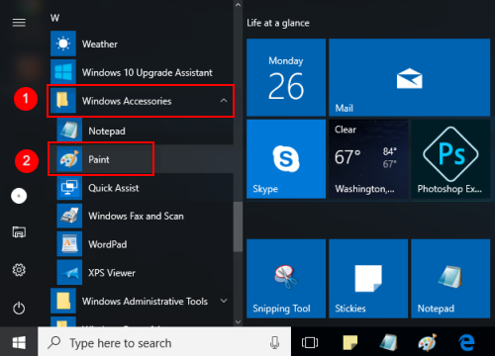

*Figure 3.1(a) Opening Paint*

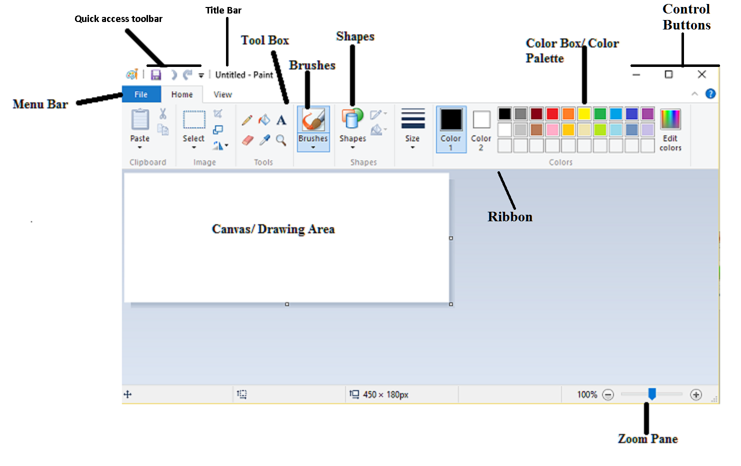***Figure 3.2(b) Paint Window***

Try It Yourself!

You can also change the size of your canvas by using

*resize* button in the Home tab. Select “Pixels” and

type the desired size in the “horizontal” and “vertical” box

Or, if you’d rather adjust the size by percentage, select

“Percentage” and enter the percentage by which you’d

like to increase or decrease the current canvas size. For example, to double the current size, type 200 into each box.

*c*

### *Menu Bar*

*The Menu Bar is located under the title bar and consists of 3 tabs.*

* ***File***

*It has options of New, Open, Save, Save As, Print, Set as Desktop Background, Properties, About and Exit.*

* ***Home***

*Home tab Consists of the Clipboard, Image box, Tools Box, Brushes, Shapes and Color Palette.*

* ***View***

*The View tab consists of the options of Zoom, Show/ Hide and Display.*

### *Tool Box*

***Tool Box*** *in Paint consists of 6 Main tools for drawing and coloring images.*

* ***Pencil***

*With the pencil tool, you can draw a free form line or drawing with the selected line width.*

* ***Fill With Color***

*Fill with color tool is used to fill desired color in the selected area of the image. Click an area on the canvas to fill it with the foreground color or right click to fill it with the background color.*

* ***Text***

*It is used to insert text into the picture.*

* ***Eraser***

*It works like a typical eraser. Eraser can be used to erase parts of the picture which will reveal the background color.*

* ***Color Picker***

*This tool can be used for picking a specific color from any part of the picture and using it in the drawing.*

* ***Magnifier***

*It can be used to change the magnification or zoom level of a part of the picture.*

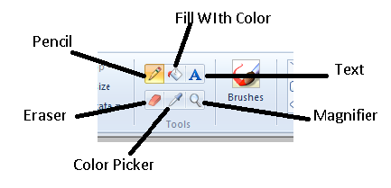

*Figure 3.3.2 Tool Box*

### *Color Palette*

*The collection of colorful boxes at the top right of paint window is known as the* ***color palette****. Clicking on a color will select it as the* ***foreground color*** *which is shown by the box labeled as Color 1 on the left side of the color palette. Whenever a paint tool such as pencil, line, brush or eraser is used, it uses the Color 1 settings. For selecting a* ***background color*** *simply click on the box labeled as Color 2 and select a color from color palette. The background color is used as a fill whenever a closed object like circle, rectangle etc is drawn or to fill a deleted area of the image. The Edit Color option on the right side of the palette allows users to customize shades according to their desire.*

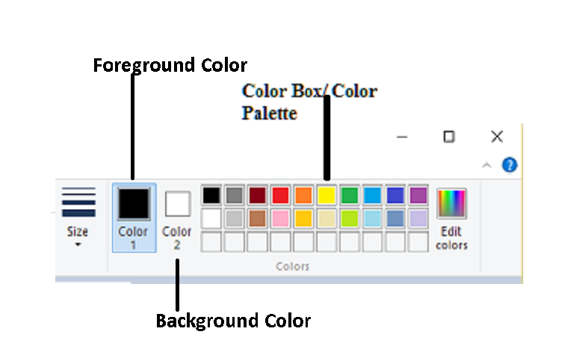

*Figure 3.4.3 Color Palette*

### *Using the Pencil Tool*

***Pencil tool*** *is much like an actual pencil. It is used for drawing freehand shapes of desired line thickness. To draw with pencil, select the pencil tool from the tool box and select your desired thickness from the Size option. Now place your mouse cursor over the canvas and press the left mouse button as you drag it along the screen. This will draw a line in the foreground color. To draw in background color, simply repeat the process with right mouse button. Fig. 3.1.4 shows lines of various thicknesses and freehand shapes drawn with pencil tool.*

*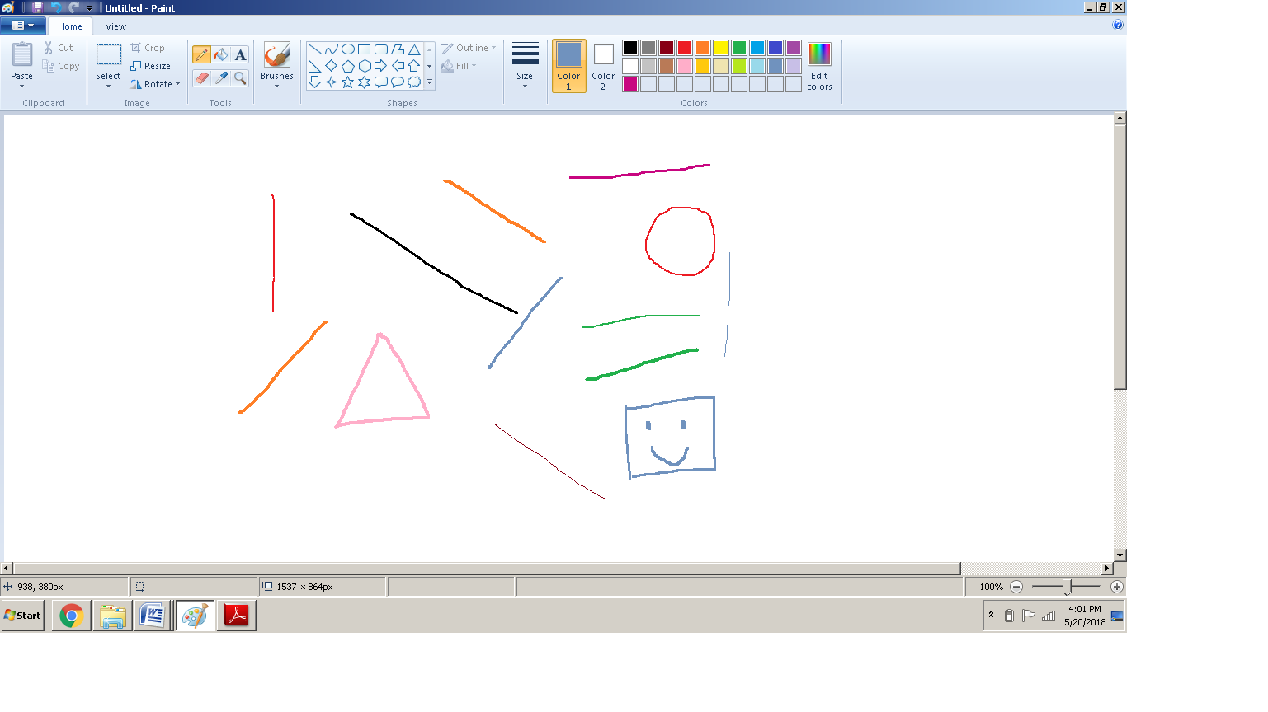 Figure 3.5.4 Pencil Tool*

### *Using Brushes*

***Brushes*** *are more versatile than the typical pencil as you can use different brush tips to create different types of strokes. Clicking on the Brushes tab will reveal 9 different types of brush tips. Their thickness can also be selected from the Size tab.*

* ***Brush***

*Brush renders a brush with a solid fully opaque color.*

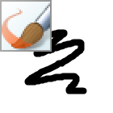

* ***Calligraphy Brush 1***

*Calligraphy Brush 1 renders a brush that mimics use of a calligraphy pen.*

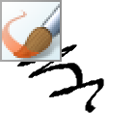

* ***Calligraphy Brush 2***

*Calligraphy Brush 2 renders a brush that mimics use of a calligraphy pen that is slightly different from calligraphy brush 1.*

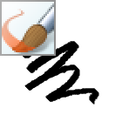

* ***Airbrush***

*Airbrush mimics the use of an actual airbrush.*

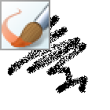

* ***Oil Brush***

*Oil Brush creates strokes similar to that used to create an oil painting.*

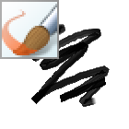

* ***Crayon***

*Crayon renders a brush that’s mimics the use of a crayon.*

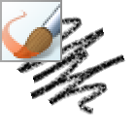

* ***Marker***

*Marker renders a brush that mimics the use of a marker.*

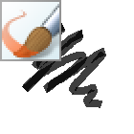

* ***Natural Pencil***

*Natural Pencil renders a brush that gives result similar to a natural pencil.*

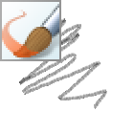

* ***Watercolor Brush***

*Watercolor brush is used to create strokes similar to that used to create a watercolor painting.*

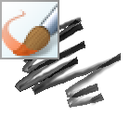

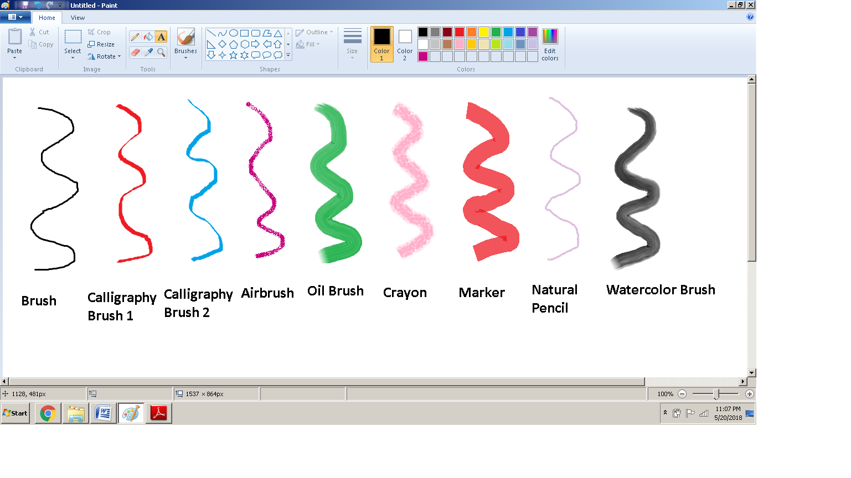

*Figure 3.6.5 Brushes*

### *Using Shapes*

***Shapes*** *tab offers a wide variety of different shapes that can be drawn on the canvas. The* ***outline*** *option is used to draw different types of outlines of the selected shape. The options available are No Outline, Solid Color, Crayon, Marker, Oil, Natural Pencil and Watercolor. The* ***fill*** *option is used to fill the selected shape with desired brush strokes of selected color. It has options of No Fill, Solid Color, Crayon, Marker, Oil, Natural Pencil and Watercolor.*

*To draw a shape, select that shape from the Shapes tab and then choose your preferred outline and fill options. Hold down the left mouse button and drag the mouse across the canvas. Release the mouse when you reach the desired shape size. If you have selected an option other than No Outline, the shape will have an outline in Color 1 and if you have selected an option other than No Fill the shape will be filled with Color 2.*

*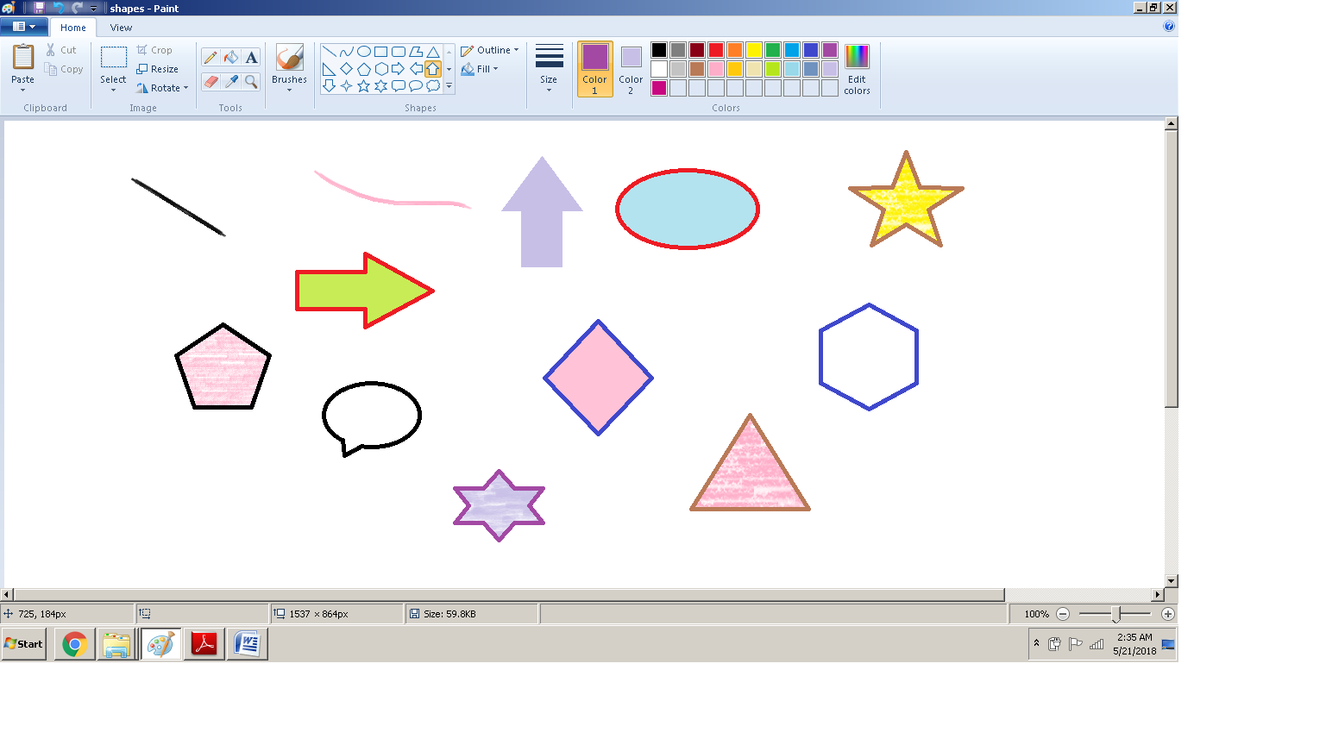****Figure 3.7.6 Shapes***

Try It Yourself!

Using the tools discussed above, try to draw a simple bear.

|  |  |
| --- | --- |
| ***1****. wpe1.jpg (4406 bytes)* | ***2****. wpe5.jpg (5108 bytes)* |
| *wpe7.jpg (6607 bytes)*  ***3*** | *wpeA.jpg (6169 bytes)*  ***4*** |
| *wpeD.jpg (6888 bytes)*  ***5*** | *wpeF.jpg (7476 bytes)*  ***6*** |

### *Copy/ Paste and Modify an Image*

* *Select the Fill with Color tool and fill the canvas with green color.*
* *Select six-point star from the Shapes tab and draw by dragging mouse over the canvas. For drawing a red shape, select solid fill from the fill tab and select red color as Color 2.*
* *Select oval from Shapes and select black color as Color 2. Draw a small black oval in the centre of star to make it a flower.*
* *Using curve tool from Shapes, draw stem of the flower.*

*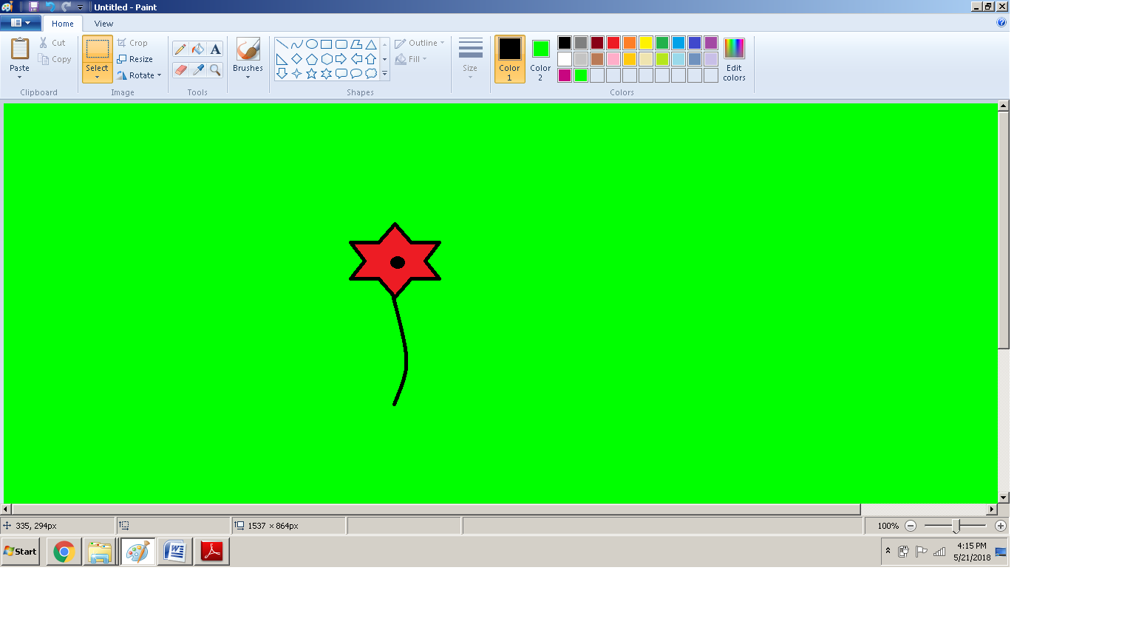****Figure 3.1.7 (a) Drawing a flower***

* *Now click on the Select tool and select the whole flower by dragging the mouse to draw a rectangle around it.*
* *Click on the Copy option located on the top left corner of Ribbon, in the clipboard tab.*
* *Click on Paste located beside copy option in the clipboard tab.*

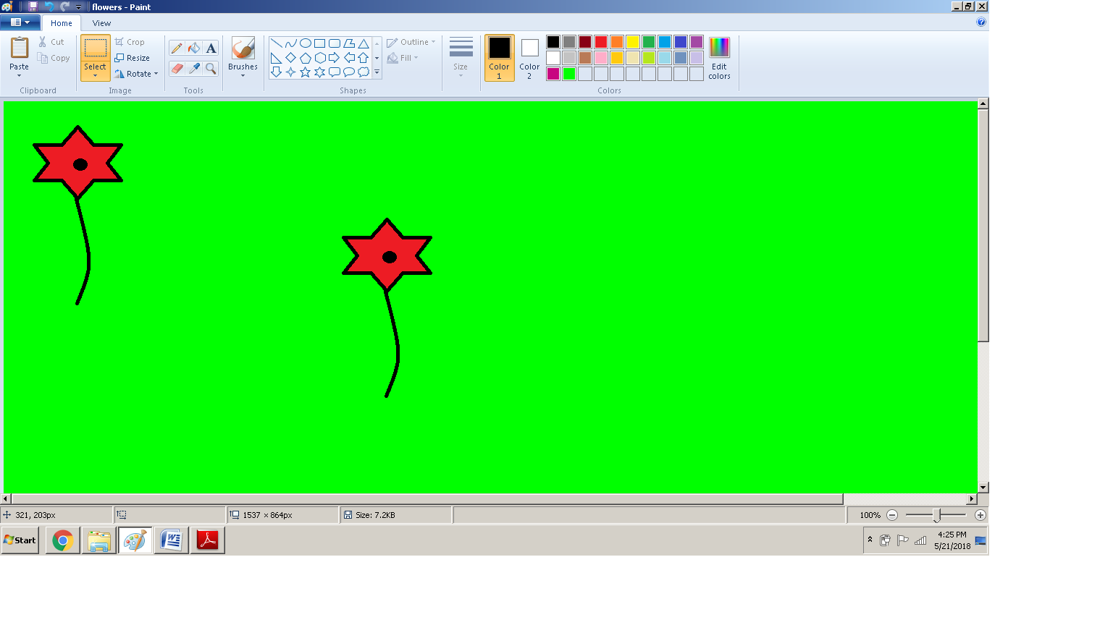

***Figure 3.1.7 (b) Copy/ Pasting the flower***

* *Select the newly pasted flower and drag it to a new location on canvas.*
* *Select any color of your choice as Color 1 and use Fill with Color to fill the pasted flower with that color.*

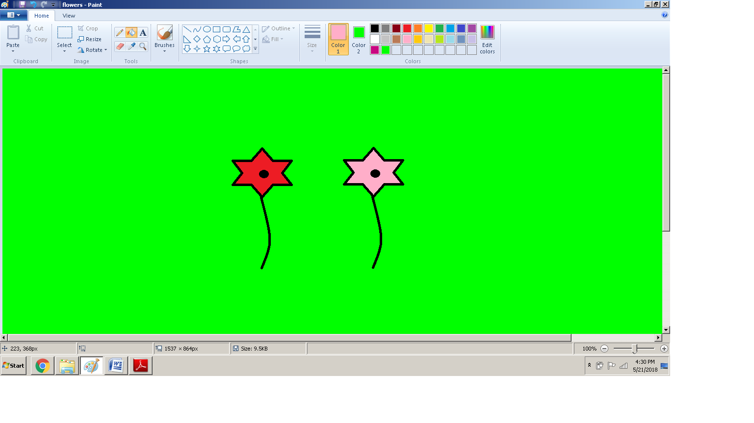 ***Figure 3.1.7 (c) Changing the color of flower***

* *Repeat above mentioned steps to draw several colorful flowers on the canvas.*
* *Select oval from Shapes. Select black color as Color1 and dark green as Color 2.*
* *Draw small ovals as leaves of the newly pasted flowers.*
* *Using the Text tool write Flowers on the top.*

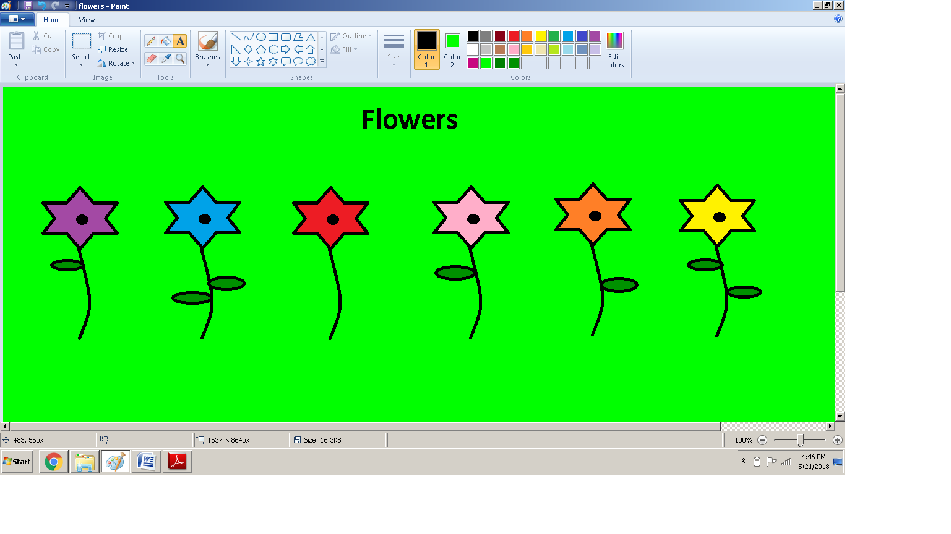 ***Figure 3.8.7 (d) Adding leaves and text***

Resize and Skew the Image

* *Select the purple flower and click on Resize option in the Image tab.*
* *The Resize and Skew window will open. In the Resize area, type 50 in the horizontal and vertical windows and click okay. This will reduce the size of selected flower by 50%.*

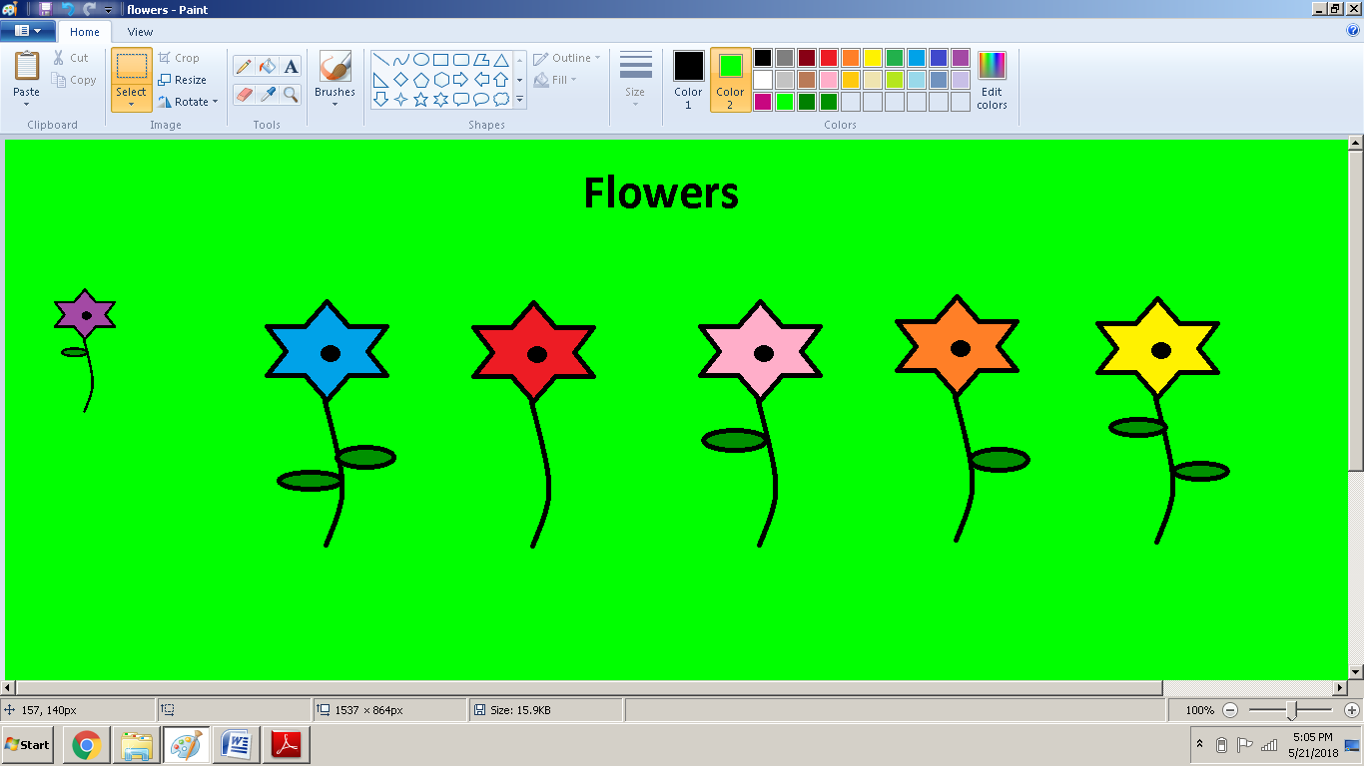

***Figure 3.1.7 (e) Resizing the flower***

* *To skew the image, repeat the above mentioned steps and type 45 in the horizontal window* in the *Skew* section*.*

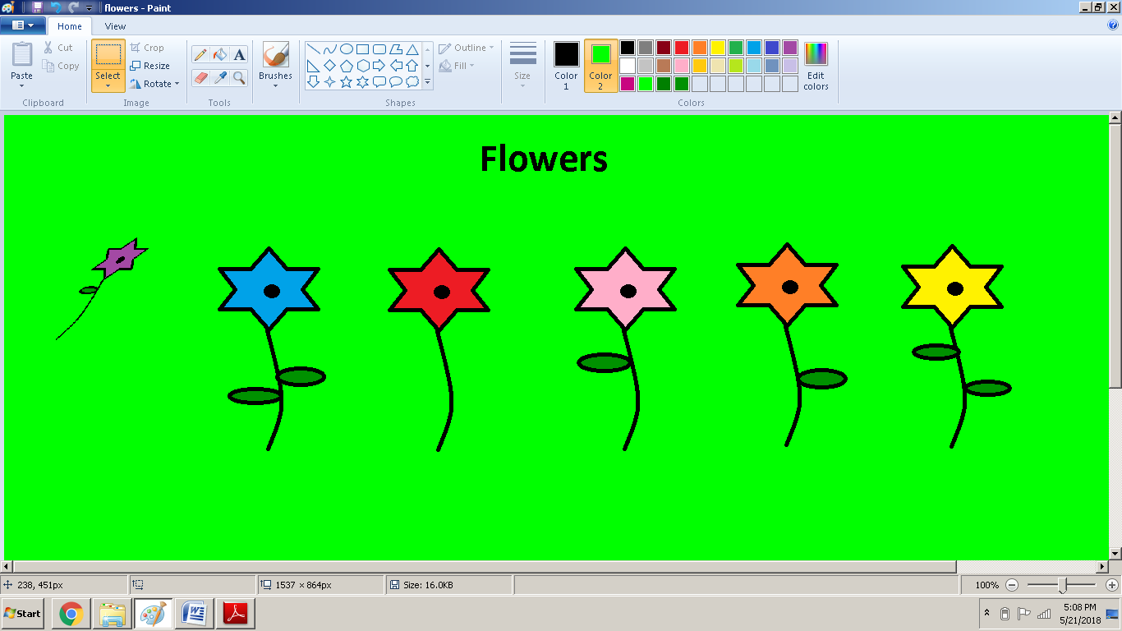 ***Figure 3.1.7 (f) Skewing the flower***

* *Now using the eraser tool, erase the skewed flower. Note that while erasing some unwanted details from the drawing, the color used in canvas which in this case is light green must be selected as Color2 as Color2 is used to fill the space revealed after erasing something. You can also delete the flower by selecting it and pressing Delete on the keyboard.*

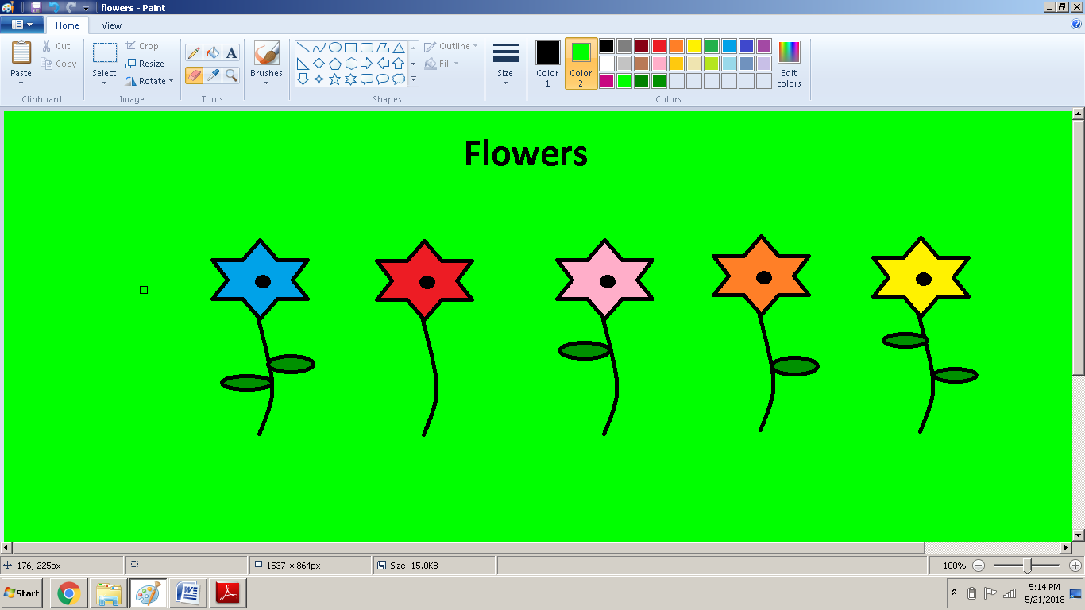

***Figure 3.1.7 (g) Erasing unwanted details***

### *Save File*

* *To save your file click on the File or the Paint button. You can also click the floppy disk image on quick access toolbar to save your file.*
* *It will drop down the list which has option of Save and Save As. Click on Save. Alternatively you can also press cltr + s. This will open the Save As dialogue box.*
* *Click on the folder where you want to save your file.*
* *Write the name of your file*
* *Click Save.*

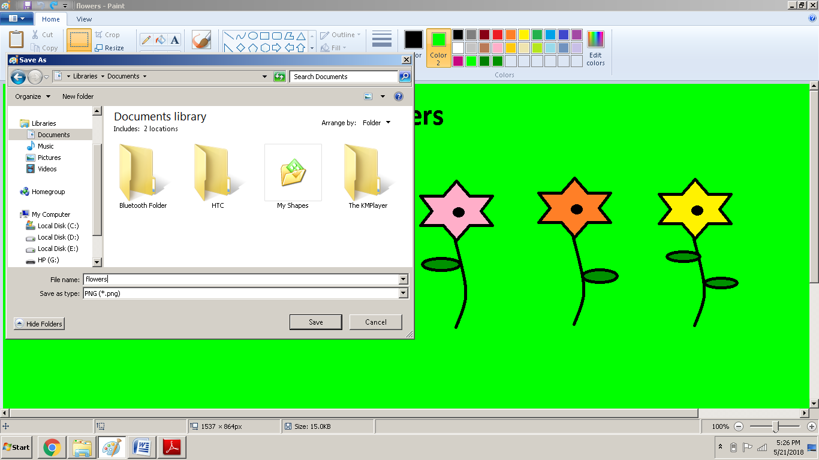

***Figure 3.1.8 Save As dialogue box***

# *3.2 Using a Typing Tutor*

***Typing****is the process of writing or inputting text by pressing keys on a typewriter, computer keyboard, cell phone, or calculator. The important things to remember while typing are*

* *Use correct fingers.*
* *There is no need to rush.*
* *We should pay attention to our posture. We should take rest, shake our hands and relax our muscles during typing.*
* *It is important not to look at our hands or the keyboard while typing.*

*A* ***typing tutor*** *is a software used to help users to learn and improve typing skills. A user can install and work on any typing tutor software. After continuous practice, the user will be able to type fastly and accurately.*

### *3.2.1 Home Keys*

*The* ***home keys*** *are the row of keys on the computer keyboard your fingers rest on when not typing****.*** *For example, on the standard QWERTY United States keyboard, the home row keys for your left-hand are A, S, D, and F and your right-hand are J, K, L, and ; (semicolon). For both hands, the thumbs rest on the spacebar.*

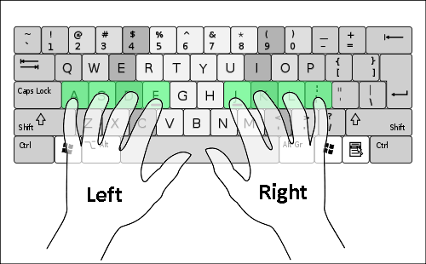

***Figure 3.2.1 Keys for left and right hand***

### *3.2.2 Correct Fingers for Typing English Text*

*The following image shows a suggested scheme for typing correct English text on a keyboard.*

*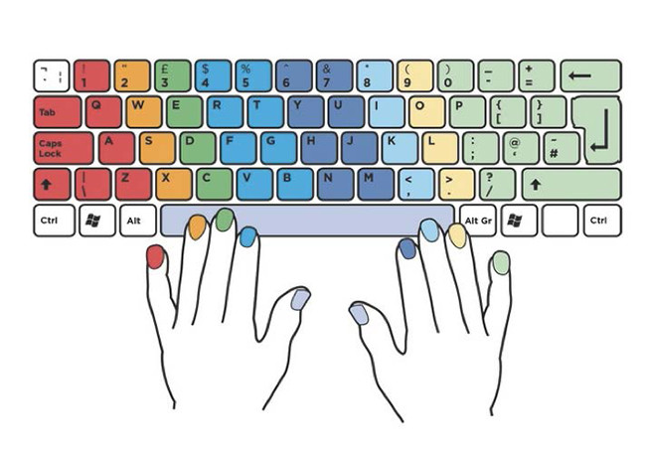****Figure 3.2.2 Correct fingers for typing English text***

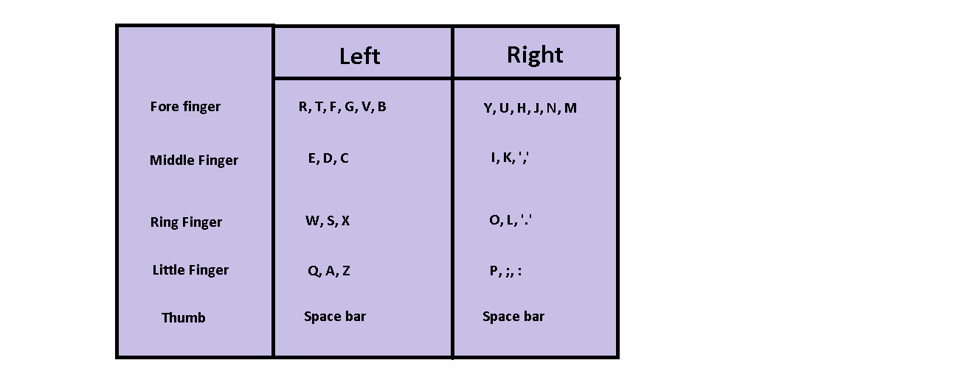

### *3.2.3 Basic Typing Skills*

*The color coded keyboard shown in Figure 3.2.2 will help you understand which finger should press which key. Following basic points should be kept in mind while typing on a keyboard:*

* *Hit keys only with the fingers for which they have been reserved.*
* *Always return to the starting position of the fingers "ASDF – JKL;".*
* *When typing, imagine the location of the symbol on the keyboard.*
* *Establish and maintain a rhythm while typing. Your keystrokes should come at equal intervals.*
* *The SHIFT key is always pressed by the little finger opposite to the one hitting the other key.*
* *Use the thumb of whichever hand is more convenient for you to press the Space bar.*

Opening the Typing Tutor

*To open the typing tutor that has been installed on your computer, which in this case is Typing Master, follow these steps*

* *Click on Start Menu*
* *Click on All Programs*
* *Click on Typing Master folder*
* *Click on Typing Master*
* *Typing Master is launched*

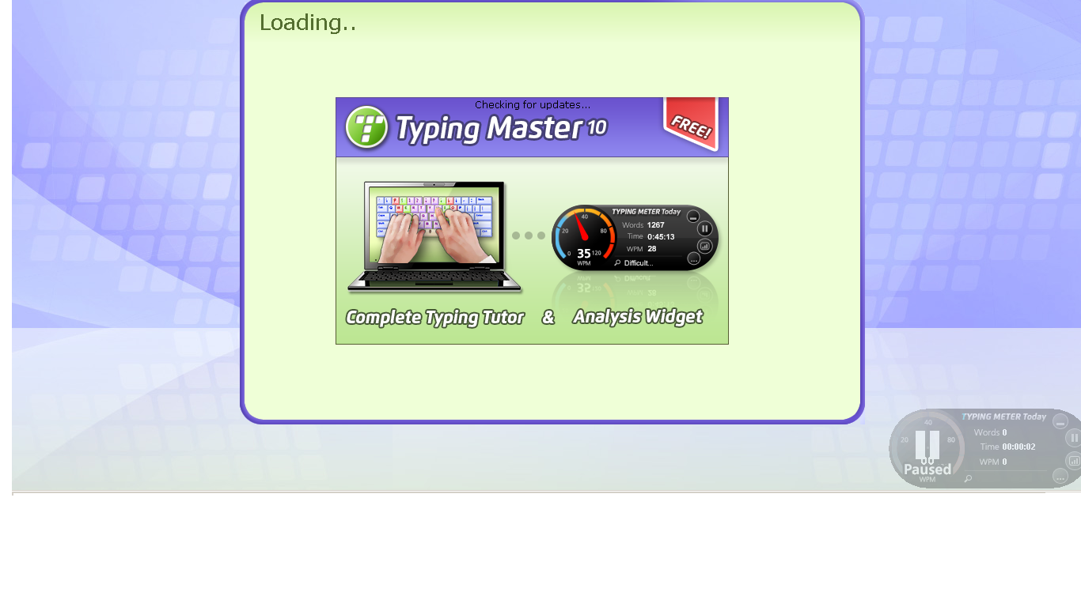 ***Figure 3.2.3 (a) Launching Typing Tutor***

* *After typing user name, first lesson appears on screen.*

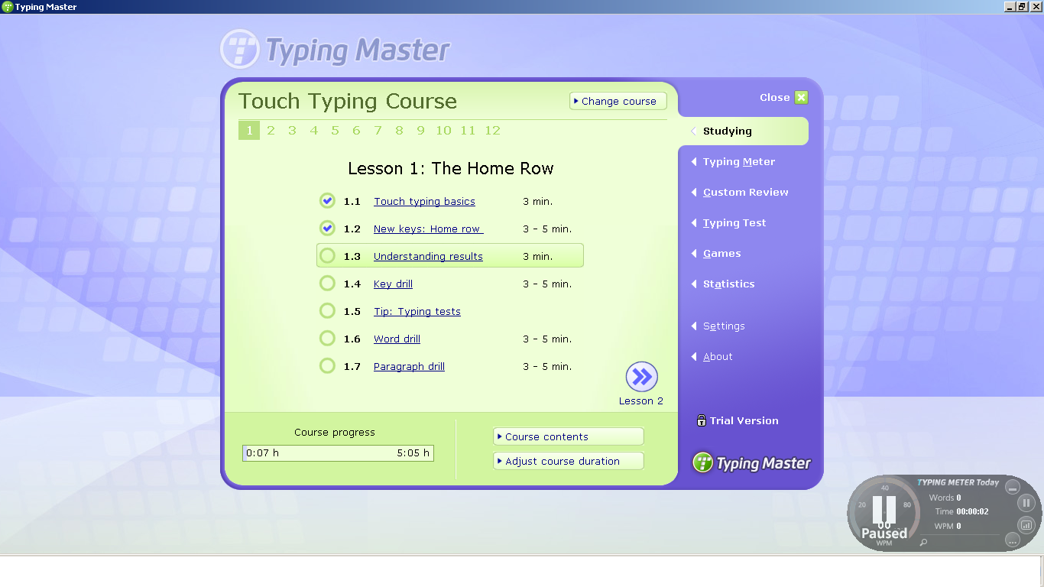 ***Figure 3.2.3 (b) Typing Tutor Courses***

* *Click on a lesson to start practicing.*

*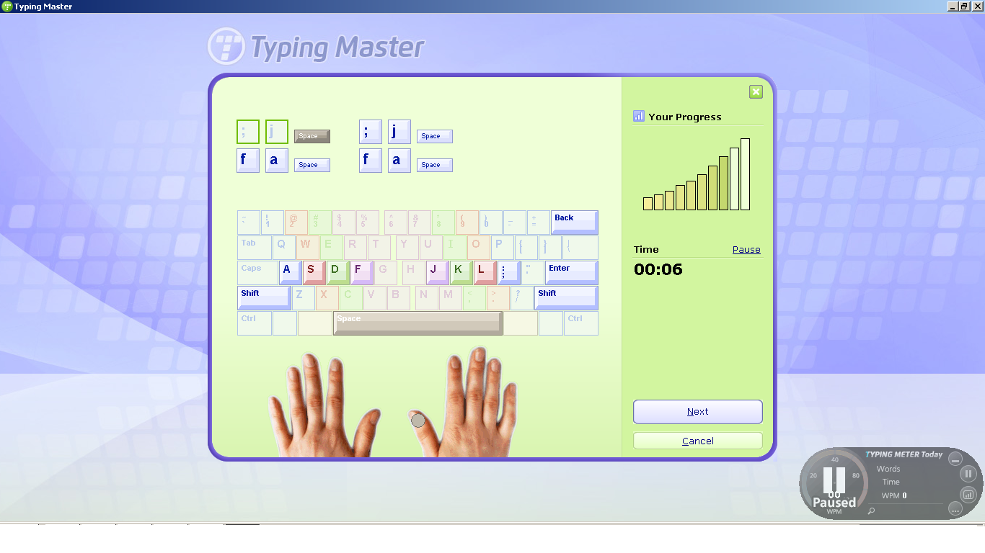****Figure 3.2.3 (c) Practicing lesson***

* *Try to take as many exercises as you can to improve your typing skills and speed*

### *3.2.4 Improve Speed and Accuracy Through Tests and Results*

*After learning and practicing all the keys, user can take a typing test to access his or her typing abilities. Speed in typing is calculated as WPM or Words Per Minute which is the number of words typed in one minute.*

Taking Tests in Typing Master

* *Open Typing Master*
* *Select the option of Typing Test from the panel at the right side of screen.*
* *Choose a test*

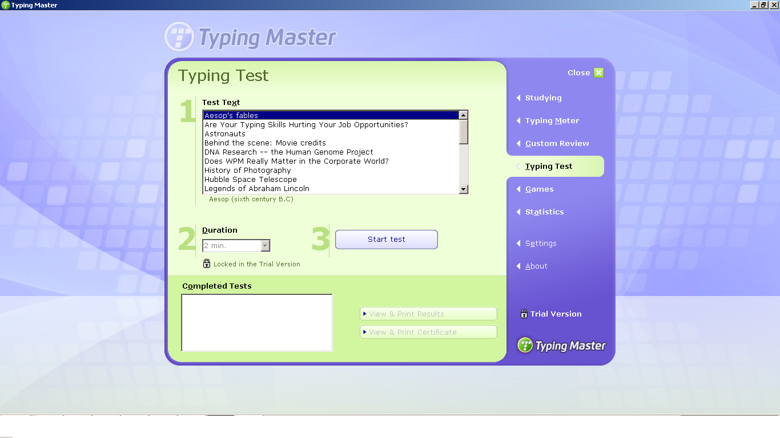

***Figure 3.2.4 (a) Typing Test***

* *Test appears. Start typing.*

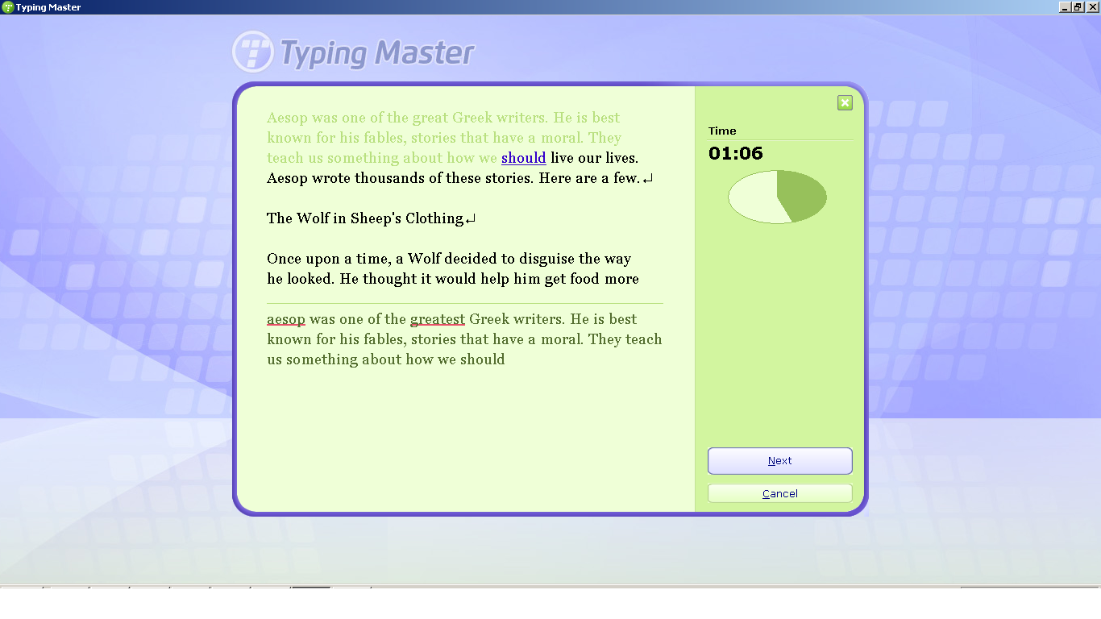 ***Figure 3.2.4 (b) Typing Test***

* *After the test is completed, Typing Master shows you your result card.*

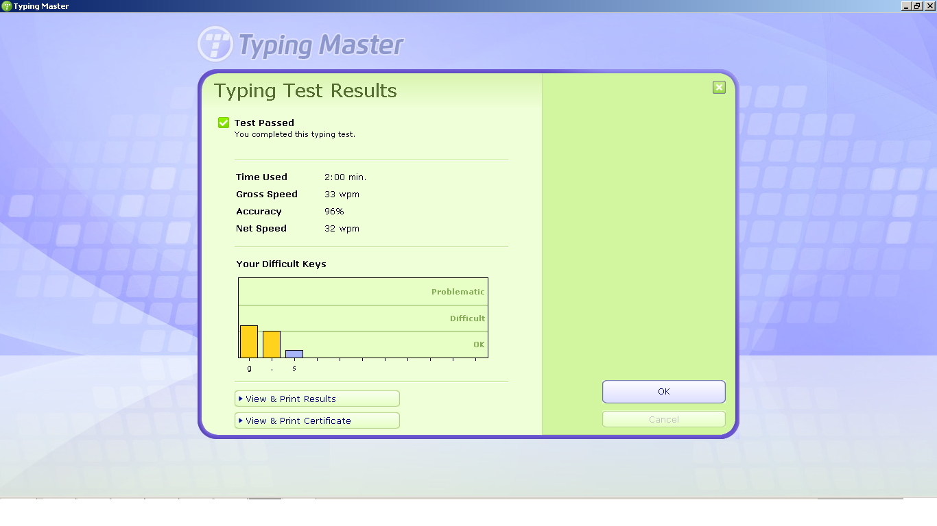 ***Figure 3.2.4 (c) Typing Test Result***

**

Try It Yourself!

The following sentence uses every alphabet atleast once

“The quick, sly fox jumped over the lazy,

brown dog by

the tall, white fence”

Challenge your friend to type this sentence and see who

can write it more accurately and faster!

# *3.3 Working with Word*

***Word Processing*** *means to create, edit and print documents using a software on a computer. The software used to produce text documents on a computer is called a* ***word processor.***

***Microsoft Word*** *or* ***MS Word*** *is the most widely used word processor and Word 2016 is its latest version.* ***Microsoft Word 2016*** *is a word processing application that allows you to create a variety of documents, including letters, resumes, and more.*

DO YOU KNOW?

While doing word processing, words are known as ‘text’ and the whole text is called a ‘document’

.

Opening MS Word

* Click Start.
* Click on Word icon. G:\PTBB\word\icon.png
* The Word 2016 opens up to the main screen.

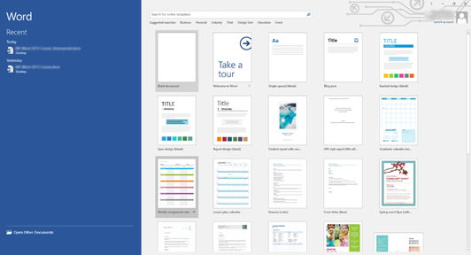

***Figure 3.3 (a) Word 2016 start screen***

*On the left, you'll see the dark blue column that contains your recently opened documents. You can click on any of these to open them. To the right, you'll see templates that you can use to start a new Word document.*

*You can also choose to just open a* ***blank Word document****.   A blank Word document is just a white, blank area. It doesn't have any formatting or dummy text added to it as a template might.*

* *To open a blank document, click on Blank Document to select it.*
* *Word 2016 then opens the blank document for you.*

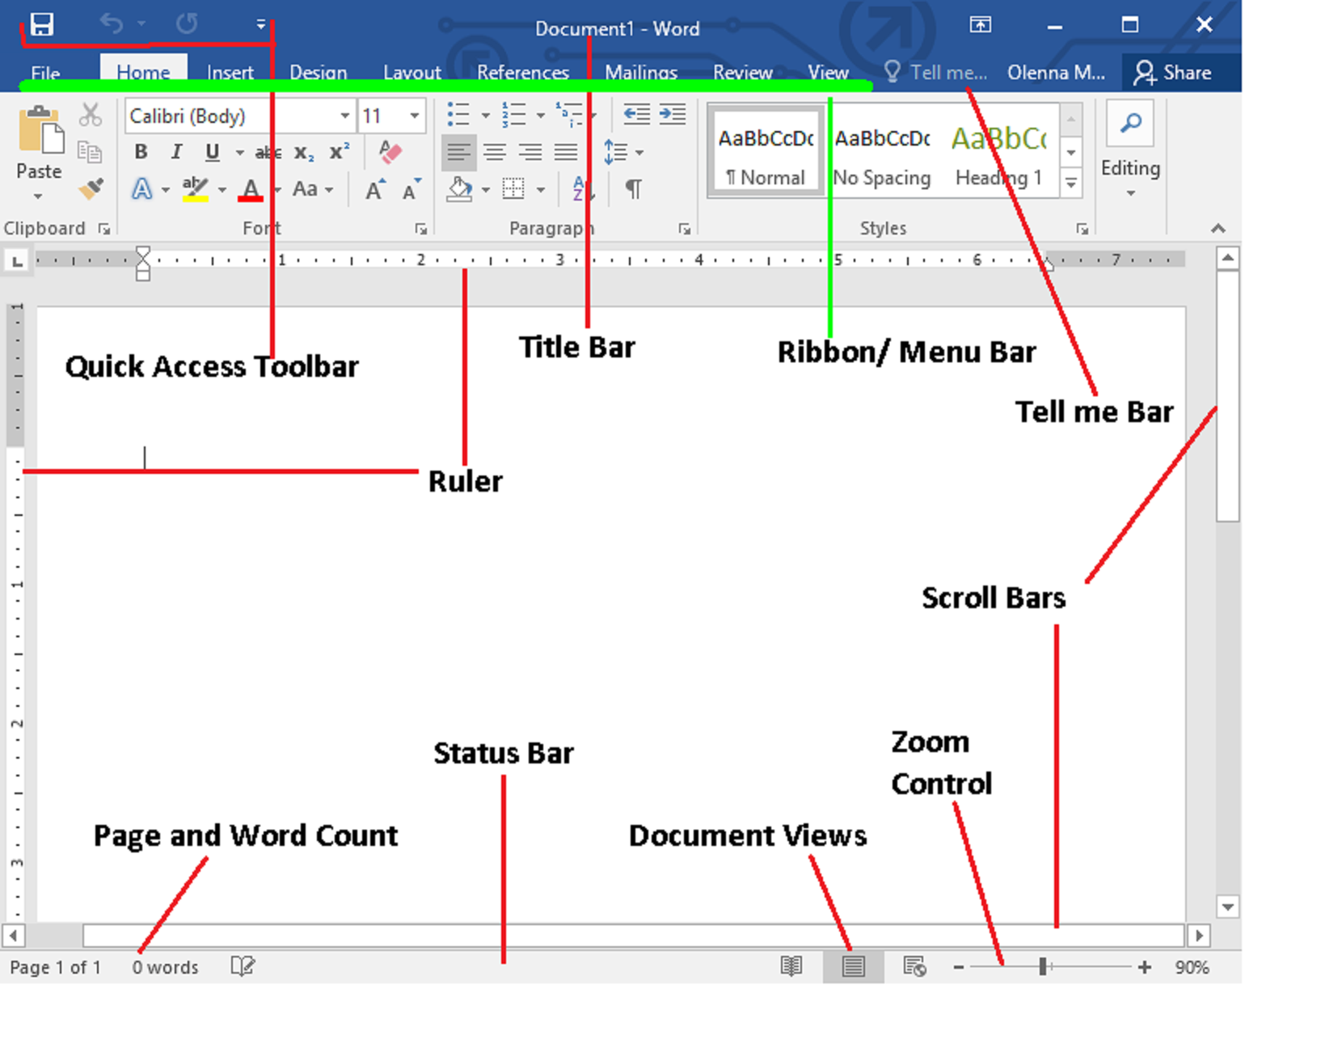

***Figure 3.3 (b) Word 2016 main screen***

***Quick Access Toolbar***

*It lets you access common commands no matter which tab are selected. By default, it includes the****Save****,****Undo****, and****Redo****commands.*

***Ribbon / Menubar***

*The****Ribbon****contains all of the commands you will need to perform common tasks in Word. It has multiple tabs, each with several groups of commands.*

*The ribbon is divided into seven tabs and each tab is a collection of several groups that show related items together:*

* ***Tab*** *is a collection of several groups of related commands.*
* ***Groups*** *show similar commands together.*
* ***Dialogue Box Launcher*** *gives access to additional commands*
* ***Command Buttons*** *are used to issue commands or to access menus and dialogue boxes.*

***The Ruler***

*The****Ruler****is located at the top and to the left of your document. It makes it easier to make alignment and spacing adjustments.*

***Document Views***

*There are three ways to view a document:*

* ***Read Mode****displays your document in full-screen mode.*
* ***Print Layout****is selected by default. It shows the document as it would appear on the printed page.*
* ***Web Layout****shows how your document would look as a webpage.*

***Page and Word Count***

*From here, you can quickly see the number of****words****and****pages****in your document.*

***Tell me***

*The****Tell me****bar allows you to search for commands, which is especially helpful if you don't remember where to find a specific command.*

***3.3.1 Creating New Document***

*To create a new blank document, follow these steps*

* *Select the File tab to access Backstage view.*

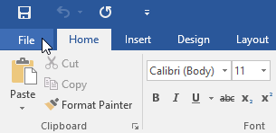

***Figure 3.3.1 (a) Select File tab***

* *Select New, then click Blank document.*

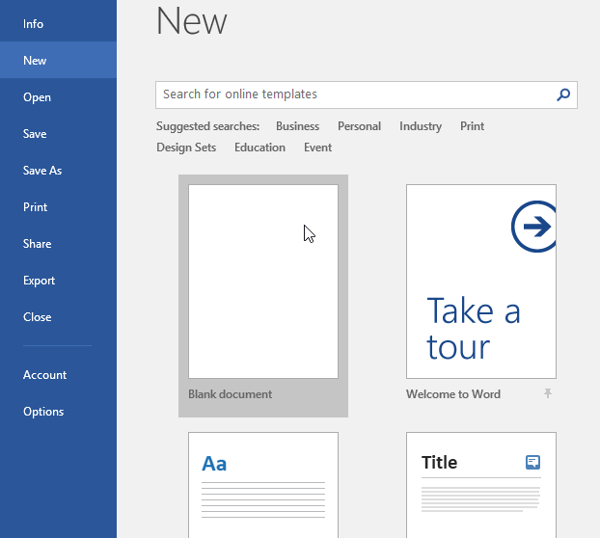

***Figure 3.3.1 (b) The backstage view***

* *A new blank document will appear.*

**

Try It Yourself!

* In the *Tell me bar* type *Shape* and press Enter.
* Choose any shape from the menu and Double-

Click somewhere on your document.

* You can also open *shapes* command from *Insert*

Tab in the *Illustrations* group

* Zoom the document to 120%
* Change the *Document View* to *Web Layout*

***3.3.2 Text Editing***

*Adding, deleting and re-arranging text in the document is called* ***text editing.***

Typing Text into the Document

*A flashing vertical line on the screen is called* ***cursor*** *or* ***insertion point****. The text we type will appear where the insertion point flashes on the screen.*

*As we type, the insertion pointer moves horizontally towards the right of the screen. When we reach the end of a line, Word automatically wraps the text to the next line.*

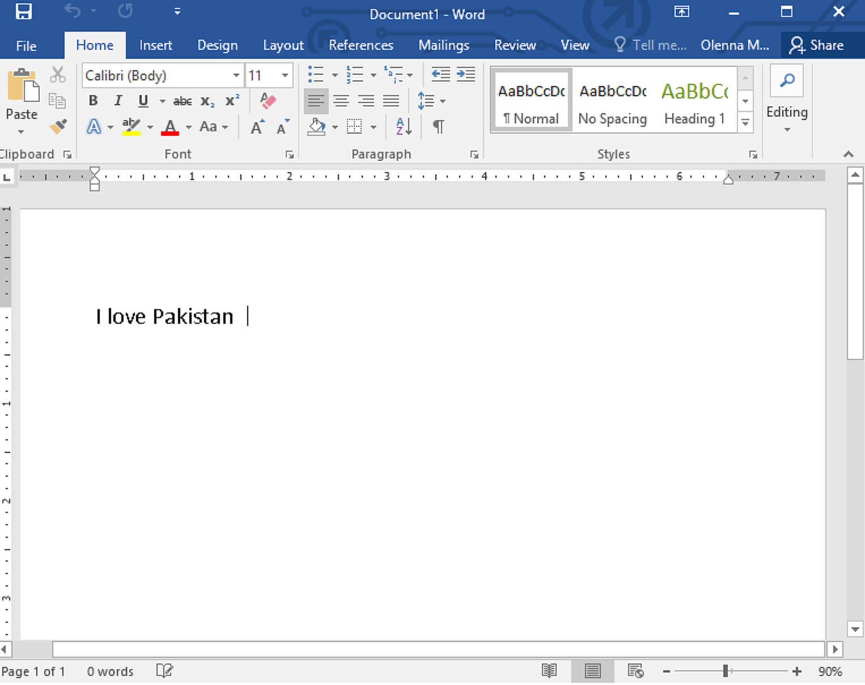 ***Figure 3.3.2 Typing text in Word 2016***

***3.3.3 Select Text***

*Before using any Word feature, a user must first* ***select*** *the required text. Selected text appears highlighted on the screen.*

*How to Select Text?*

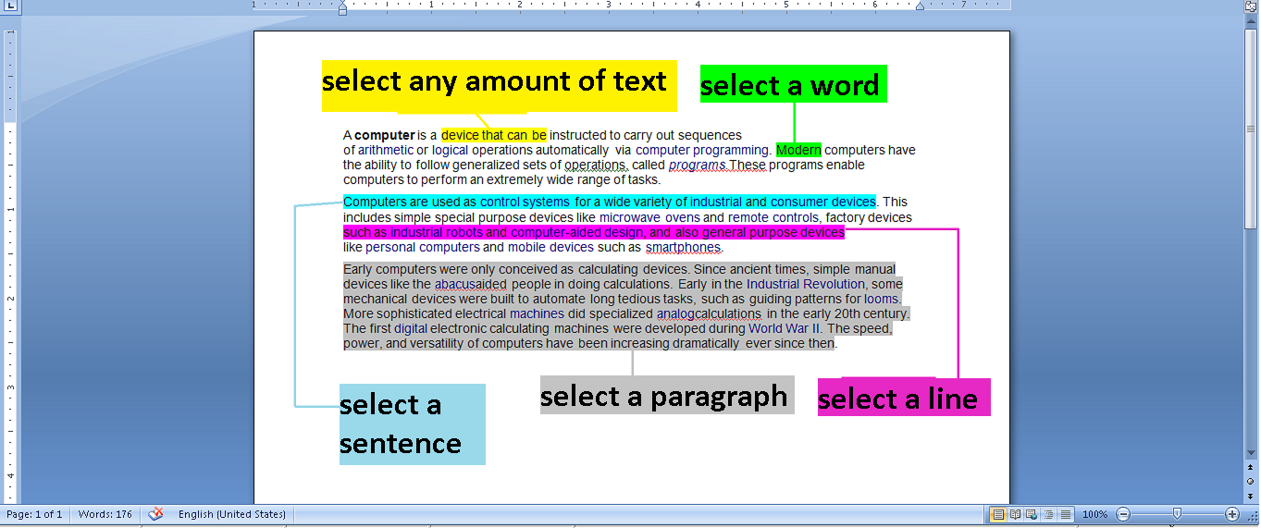 ***Figure 3.3.3 Selecting text***

* ***Select any amount of text***

*Just drag the mouse pointer over the text while holding down left mouse click or hold the shift key and press arrow keys.*

* ***Select a word***

*Move the mouse anywhere over the word you want to select and double click the word*

* ***Select a sentence***

*Hold down the control key and then click anywhere in the sentence.*

* ***Select a line***

*Move the mouse towards left of the line until it changes to a right-pointing arrow and then click.*

* ***Select a paragraph***

*Move the mouse to the left of a paragraph until it changes to a right- pointing arrow and then double click.*

* ***Select entire document***

*Move the mouse pointer to the left of paragraph until it changes to a right-pointing arrow and then triple click. Alternatively press Ctrl + A.*

DO YOU KNOW?

You can also select text with the keyboard by:

* Holding the *Shift keys* while using the arrow keys to expand the highlight
* Holding the Ctrl + *Shift* keys while using arrow keys to select word by word.



.

***3.3.4 Cut/ Copy Text***

*The* ***copy command*** *creates a duplicate of the selected text, leaving the original text unchanged. The* ***paste command*** *pastes the copied text at the insertion point. When we copy and paste the text, it appears in both original and new location.*

* *Select the text and click the copy option in the clipboard tab at top left corner or press Ctrl + C.*

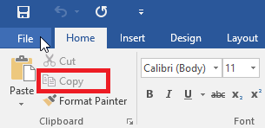

***Figure 3.3.4 (a) Copying text***

* *Move the cursor where text has to be pasted and click on the paste option beside copy button or press Ctrl + V.*

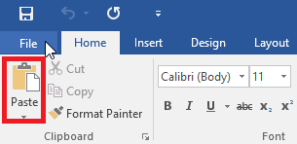

***Figure 3.3.4 (b) Pasting text***

*A user can move text from one position to another in a document using the cut and paste commands. The* ***Cut*** *command deletes the selected text from its original location. The paste command then places this text at the insertion point.*

* *Select the text and click the Cut option in the clipboard tab or press Ctrl + X.*

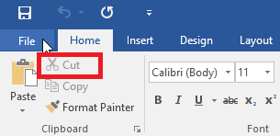

***Figure 3.3.4 (c) Cutting text***

* *Move the cursor where text is to be placed and click the paste button or press Ctrl + V.*

**

Try It Yourself!

* Make a list of provinces of Pakistan (Sindh, Balochistan,

Khyberpakhtoon Khawa, Punjab)

* Copy and paste a duplicate of this list.
* Now cut and paste the names of provinces such as the most

populated province comes first.

***3.3.5 Deleting Text***

*Removing text from a document is known as* ***deleting.*** *A user can remove unwanted text from document by following methods:*

* ***To delete a single character***

*Place the cursor to the right of character and press the backspace key.*

* ***To delete a block of text***

*Select the text and press Delete key.*

***3.3.6 Fonts***

***Text formatting*** *allows you to change the appearance and layout of text and other characters within a document. The* ***font*** *determines the way your text appears on your screen and when you print the document. There are more than several different types of font. The more common types are Times New Roman, Calibri and Verdana. You can apply a font to either an entire document or to certain portions of a document.*

*Changing Font Style*

* *To apply a font, click on the Home tab and go to the Font group.*

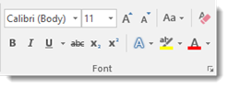

***Figure 3.3.6 (a) Fonts***

* The current type of font is *Calibri*. You can click on the downward arrow in that window to display other types of fonts available to use.

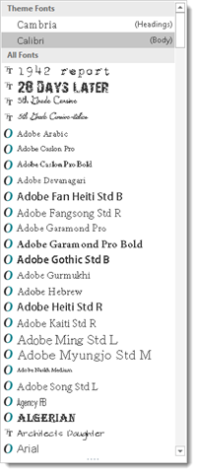

***Figure 3.3.6 (b) Font Styles***

* To change the type of font within a document or for the entire document, simply select the text to be formatted and select a new font.

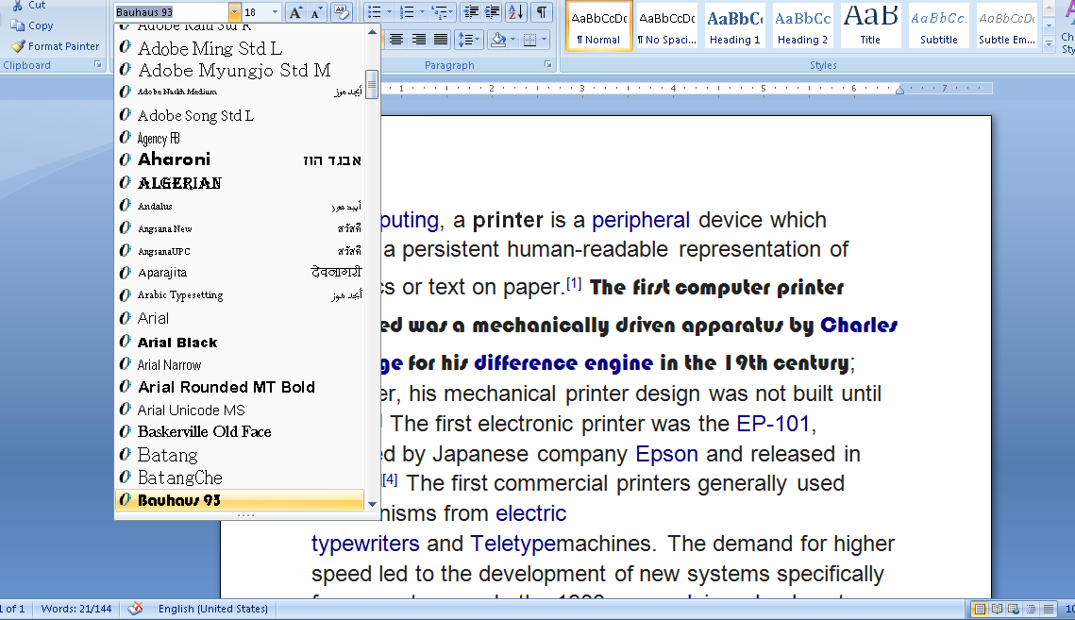

***Figure 3.3.6 (c) Changing Font Style***

* To change the font of color, select the font to be changed and select a color by clicking on the drop down arrow beside **A** button in the *Font* group.

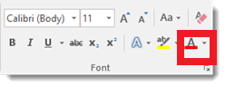

***Figure 3.3.6 (d) Changing Font Color***

*Changing Font Size*

In addition to changing the type of font, you can also change the font size. Next to the type of font under the Home tab is a box that states the size of font currently being used. Our current font size is 11.

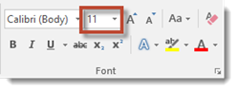

***Figure 3.3.6 (d) Font Size***

Try It Yourself!

* Write your complete name in a document example Ali Usman.
* Copy and paste it two times and press enter after each name.

Ali Usman

Ali Usman

Ali Usman

* Select the first line and click the button ***B***in the *font* group.
* Select the second line and click the button ***I***in the *font*

group.

* Select the third line and click the button ***U***in the *font* group.
* You should see something like this

**Ali Usman**

*Ali Usman*

Ali Usman

**

*s*

To change the size of the font, simply select the text that you want to be changed.

* Select the new font size. You can change an entire document or just a portion.
* You can also use the two uppercase A's beside the font size box to change the size of fonts you're currently using. Clicking the larger A will increase your font size by one for each time it's clicked. On the other hand, clicking the smaller A will decrease the font size by one for each time it's clicked.

*Changing Font Alignment*

***Alignment*** *determines the appearance and orientation of the edges of the paragraph. Alignment of text can be changed by using alignment buttons in the paragraph group on the ribbon.*

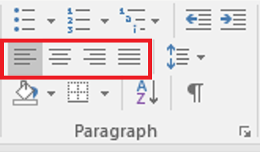

***Figure 3.3.6 (e) Font Alignment***

* ***Left Align G:\PTBB\word\al.gif***

*It aligns text at the left margin. This is the default setting.*

* ***Center G:\PTBB\word\cent.gif***

*The text is centralized. It can be used in a card or an envelope and in a listing.*

* ***Right Align G:\PTBB\word\ar.gif***

*It aligns text at the right margin. This can be used for addresses.*

* ***Justify G:\PTBB\word\just.gif***

*It aligns text to both left and right margins, adding extra space between words as necessary. This creates a clean look along the left and right side of the page.*

**

Try It Yourself!

* Write a short poem

“Early to Bed

And early to rise

Makes a man

Healthy and wise”

* Press Ctrl + A to select all text
* In the *paragraph* group, click on each *Align* icon one by one

to see new layouts

***3.3.7 Changing the Case of Text***

*We can change the selected text to UPPERCASE, lowercase or other cases.*

* *Select the text that you want to format.*
* *Click the Change Case option in the Font group.*
* *A drop down menu will be opened with options for changing case of the selected text.*

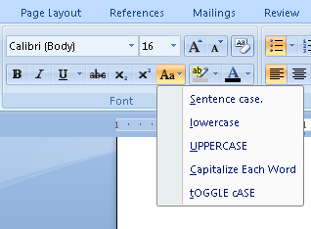

***Figure 3.3.7 Change Case***

* *Select an option. Your text will be formatted according to the selected option.*
* ***Sentence case***

*First character in the sentence is in uppercase and the rest are in lower case.*

* ***Lowercase***

*All characters are in lowercase (small letters)*

* ***UPPERCASE***

*All characters are in uppercase (capital letters)*

* ***Capitalize Each Word***

*First letter of each word of selected text is capital and rest is small.*

* ***tOGGLE cASE***

*First letter of each word is small and rest is capital.*

**

Try It Yourself!

* Write your name in a new document. Example “Ali Ahmed”
* Select you name.
* On the *Home* tab, in the *Font* group, click on *Change Case*

option.

* Select “UPPERCASE” from the drop down menu.
* Your name will change to “ALI AHMED”
* Now try using all other options.

***3.3.8 Check Spellings and Grammar***

*3.3.8.1 Automatic Spellings and Grammar Check*

*By default, Word automatically checks your document for spelling and grammar errors, so you may not even need to run a separate check. These errors are indicated by colored wavy lines. The red line indicates a misspelled word. The blue line indicates a grammatical error, including misused words.*

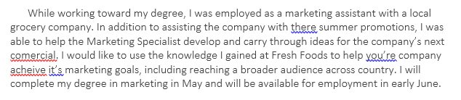 ***Figure 3.3.8.1 (a) Spellings and grammar errors***

*To correct spelling errors*

* *Right-click the underlined word, then select the correct spelling from the list of suggestions.*

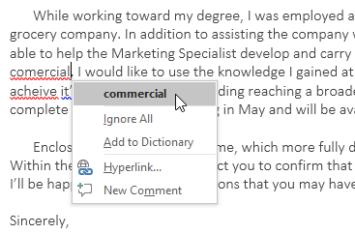

***Figure 3.3.8.1 (b) Correcting spelling errors***

* *The corrected word will appear in the document.*

*To correct grammatical errors*

* *Right-click the underlined word or phrase, then select the correct spelling or phrase from the list of suggestions.*

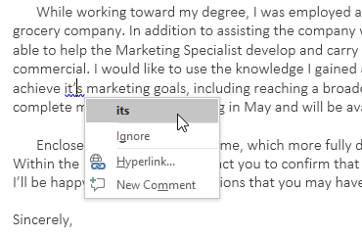

***Figure 3.3.8.1 (c) Correcting grammar errors***

* *The corrected phrase will appear in the document.*

*3.3.8.2 To Run a Spellings and Grammar Check*

* *From the Review tab, click the Spelling & Grammar command.*

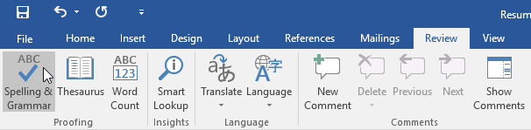

***Figure 3.3.8.2 (a) Spelling and grammar check***

* *The Spelling and Grammar pane will appear on the right. For each error in your document, Word will try to offer one or more suggestions. You can select a suggestion and click Change to correct the error.*

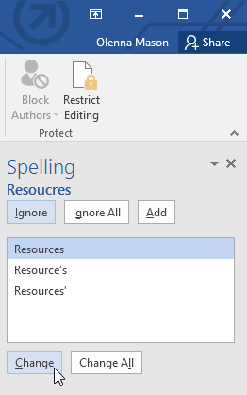

***Figure 3.3.8.2 (b) Spellings check***

* *Word will move through each error until you have reviewed all of them. After the last error has been reviewed, a dialog box will appear confirming that the spelling and grammar check is complete. Click OK.*

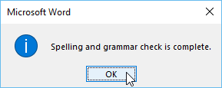

***Figure 3.3.8.2 (c) Complete Spelling and grammar check***

#### For spelling errors

* ***Ignore****: This will skip the word without changing it.*
* ***Ignore All****: This will skip the word without changing it, and it will also skip all other instances of the word in the document.*
* ***Add****: This adds the word to the dictionary so it will never come up as an error. Make sure the word is spelled correctly before choosing this option.*

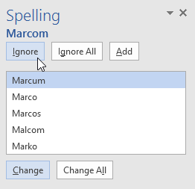

***Figure 3.3.8.2 (d) Ignore, Ignore All, Add***

#### For grammar errors

* ***Ignore****: This will skip the word or phrase without changing it.*

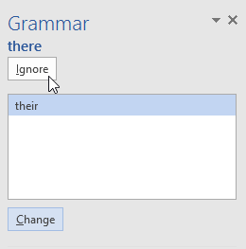

***Figure 3.3.8.2 (e) Ignore grammar check***

* ***Change:*** *It will change your written phrase to the correct option offered by the Word.*

***3.3.9 Saving a Document***

*It is important to save your document**whenever you start a new project or make changes to an existing one. Saving early and often can prevent your work from being lost. You will also need to pay close attention to where you save the document so it will be easy to find later.*

*Word offers two ways to save a file:****Save****and****Save As****. These options work in similar ways, with a few important differences.*

* ***Save:*** *When you create or edit a document, you will use the Save command to save your changes. When you save a file, you will only need to choose a file name and location the first time. After that, you can click the Save command to save it with the same name and location.*
* ***Save As****: You will use this command to create a copy of a document while keeping the original. When you use Save As, you will need to choose a different name and/or location for the copied version.*

*To save the current document, follow these steps:*

* *Locate and select the Save command on the Quick Access Toolbar.*

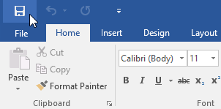

***Figure 3.3.9 (a) Select save command***

* *If you are saving the file for the first time, the Save As pane will appear in Backstage view.*

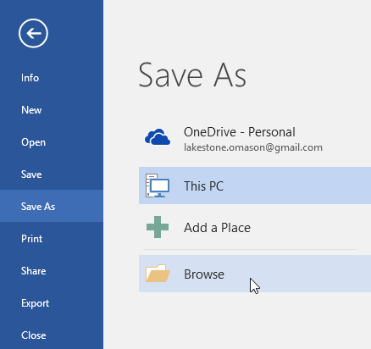

***Figure 3.3.9 (b) Save As***

* *You will then need to choose where to save the file and give it a file name. Click Browse to select a location on your computer. Alternatively, you can click OneDrive to save the file to your OneDrive.*
* *The Save As dialog box will appear. Select the location where you want to save the document.*

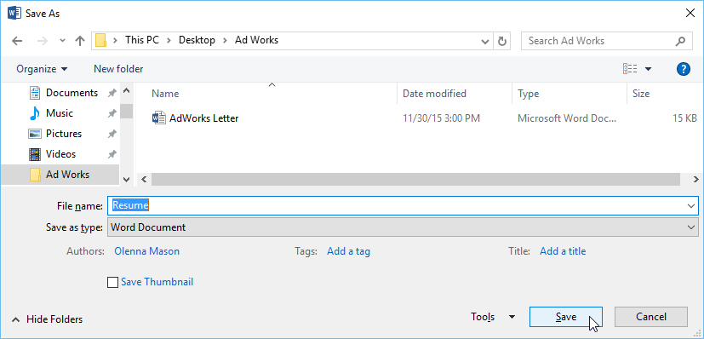

***Figure 3.3.9 (c) Save As dialogue box***

* *Enter a file name for the document, then click Save.*
* *The document will be saved. You can click the Save command again to save your changes as you modify the document.*
* *You can also access the Save command by pressing Ctrl+S on your keyboard.*

DO YOU KNOW?

OneDrive is a file hosting service operated by Microsoft as part of its suite of Office Online services. It allows users to store files as well as other personal data in the cloud.



.

***3.3.10 Printing a Full Document***

*Once you have created your document, you may want to print**it to view and share your work offline. It's easy to preview and print a document in Word using the Print pane.*

* *Select the File tab. Backstage view will appear.*

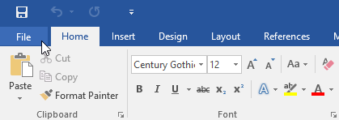

***Figure 3.3.10 (a) Select file tab***

* *Select Print. The Print**pane will appear.*

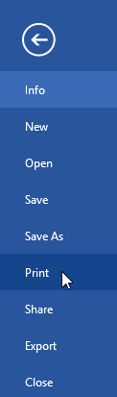

***Figure 3.3.10 (b) print pane***

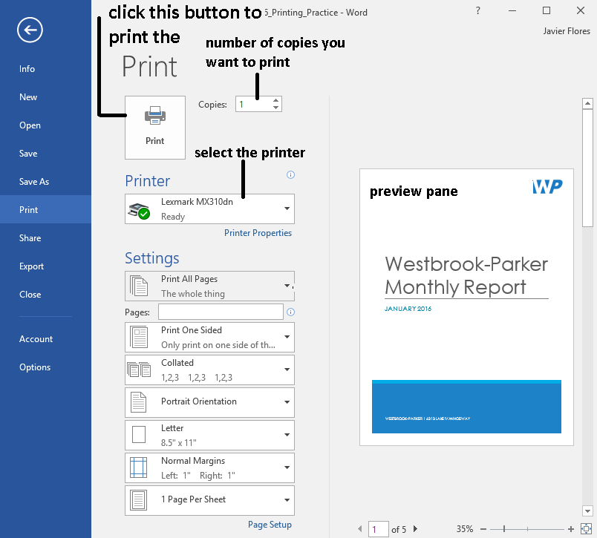

***Figure 3.3.10 (c) Print window***

* *Select the desired**printer.*
* *Enter the number of copies you want to print.*
* *Select any additional settings if needed.*

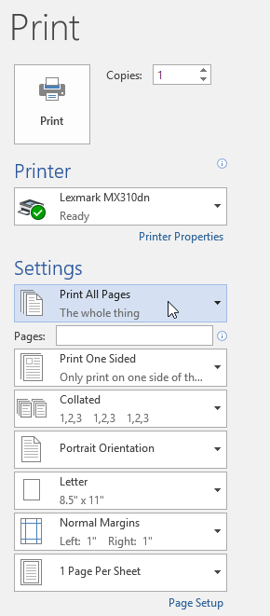

***Figure 3.3.10 (d) additional settings***

* + ***Print Range***

*Here, you can choose to print the entire document, just the current page, or custom print to print specific pages.*

* + ***Single and Double Sided Printing***

*Choose whether to print on one or both sides of the paper, if your printer supports this setting.*

* + ***Collated***

*If you are printing multiple copies, you can choose how the pages will be sorted. Collated will sort them 1, 2, 3, 1, 2, 3. Uncollated will sort them 1, 1, 2, 2, 3, 3.*

* + ***Potrait Orientation***

*Here, you can choose portrait (vertical) or landscape (horizontal) orientation.*

* + ***Letter***

*You can choose the paper size you want to use, if your printer supports this setting.*

* + ***Normal Margins***

*Here you can adjust the page margins.*

* + ***One Page per Sheet***

*This option allows you to print more than one page on a single sheet or scale the document to fit a specific paper size.*

* *Click Print.*
* *The printer will start printing out your document.*

# *3.4 Using Media Player*

***Windows Media Player*** *is a software which plays audio and video files. In this player we can watch movies and listen to songs from CD/DVD or from already stored video and audio files in the computer.*

Opening Media Player

*You can load Windows Media Player in Windows 10 by double-clicking its icon in the Start menu or taskbar.*

* *Click the Windows icon from the bottom-left corner of the screen. This will open the Start Menu.*
* *Click on All apps**to view all apps in alphabetical order.*

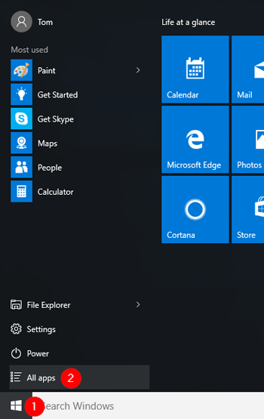

***Figure 3.4 (a) opening media player***

* *Scroll down to the letter “W” in the list. Expand the “Windows Accessories” folder and you can find the shortcut named “Windows Media Player“.*

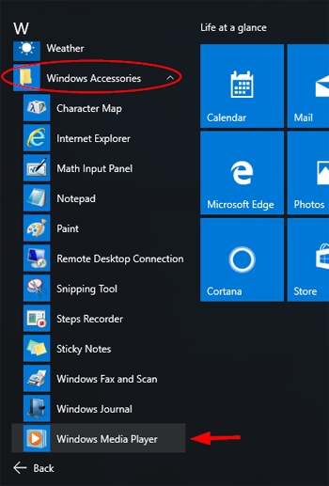

***Figure 3.4 (b) opening media player***

* *Click on it to launch Windows Media Player.*

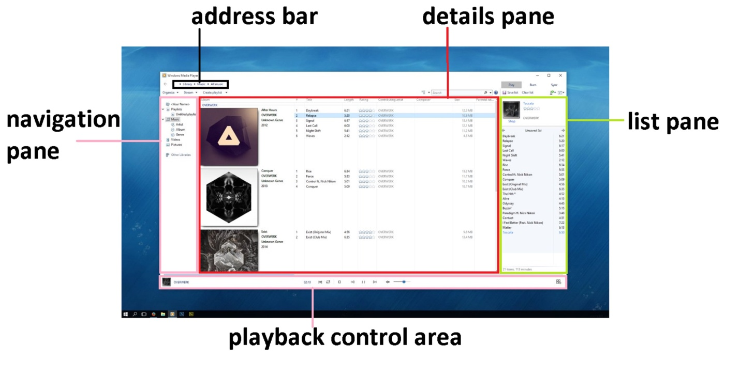 ***Figure 3.4 (c) windows media player***

***3.4.1 Playback Controls***

*The buttons used to control audio/video file in media player are known as* ***playback controls.*** *There are several playback controls in media player. Some of the most important controls are discussed below.*

* ***Play/ Pause***

*This button is used to play and pause any audio/video file. When a file is playing, it turns into pause button and when a user pauses a file it turns into play button.*

*G:\PTBB\wmp\play.png*

***Figure 3.4.1 (a) play button***

*G:\PTBB\wmp\pause.png*

***Figure 3.4.1 (b) pause button***

* ***Stop***

*Stop button is used to stop any file playing in media player from playing. A user can play it again by clicking on play button. The file will start playing from the beginning.*

*G:\PTBB\wmp\stop.png*

***Figure 3.4.1 (c) stop button***

* ***Rewind/ Fast Forward***

*These buttons are used to control the speed of file or to jump to the previous/next file. User can fast forward a file by holding down on fast forward button and can jump to next file by clicking on it once. By clicking on the previous button the previous file in the playlist starts playing and the file rewinds by holding down that button.*

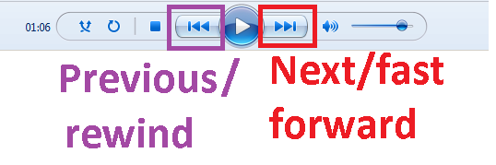 ***Figure 3.4.1 (d) rewind/fast forward***

* ***Volume and Mute***

*The volume slider is used to control the volume level of the file. A user can move the slider to the right to increase the volume and left to decrease it. You can also turn off the volume by clicking on the mute button.*

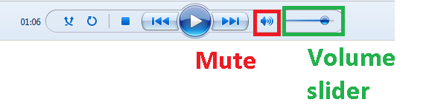 ***Figure 3.4.1 (e) mute/volume buttons***

***3.4.2 Playing a Recorded Clip from CD/DVD***

*Media player can be used to play audio and video files on cds and dvds.*

* *Insert the disc you want to play into the drive. Typically, the disc will start playing automatically. If it doesn't play, or if you want to play a disc that is already inserted, open Windows Media Player, and then, in the Player Library, select the disc name in the navigation pane.*
* *If you inserted a DVD, select a DVD title or chapter name.*

*SUMMARY*

* *Microsoft Paint is used to draw, color and edit pictures and graphics.*
* *With the pencil tool, you can draw a free form line or drawing with the selected line width.*
* *Fill with color tool is used to fill desired color in the selected area of the image*
* *The collection of colorful boxes at the top right of paint window is known as the* ***color palette***
* ***Brushes*** *are more versatile than the typical pencil as you can use different brush tips to create different types of strokes.*
* ***Shapes*** *tab offers a wide variety of different shapes that can be drawn on the canvas*
* *The* ***outline*** *option is used to draw different types of outlines of the selected shape*
* *The* ***fill*** *option is used to fill the selected shape with desired brush strokes of selected color.*
* *You can also click the floppy disk image on quick access toolbar to save your file.*
* ***Typing*** *is the process of writing or inputting text by pressing keys on a typewriter, computer keyboard, cell phone, or calculator*
* *A* ***typing tutor*** *is a software used to help users to learn and improve typing skills*
* *The* ***home keys*** *are the row of keys on the computer keyboard your fingers rest on when not typing****.*** *the home row keys for your left-hand are A, S, D, and F and your right-hand are J, K, L, and ; (semicolon).*
* *Speed in typing is calculated as WPM or Words Per Minute which is the number of words typed in one minute.*
* ***Word Processing*** *means to create, edit and print documents using a software on a computer.*
* ***Microsoft Word 2016*** *is a word processing application that allows you to create a variety of documents, including letters, resumes, and more.*
* *In MS Word, the ribbon is divided into seven tabs and each tab is a collection of several groups that show related items together*
* *The ruler is used to make alignment and spacing adjustments.*
* *Adding, deleting and re-arranging text in the document is called* ***text editing.***
* *Before using any Word feature, a user must first* ***select*** *the required text. Selected text appears highlighted on the screen.*
* *The* ***copy command*** *creates a duplicate of the selected text, leaving the original text unchanged*
* *The* ***paste command*** *pastes the copied text at the insertion point.*
* *A user can move text from one position to another in a document using the cut and paste commands. The* ***Cut*** *command deletes the selected text from its original location*
* *Removing text from a document is known as* ***deleting***
* ***Text formatting*** *allows you to change the appearance and layout of text and other characters within a document.*
* *The* ***font*** *determines the way your text appears on your screen and in your printed document.*
* ***Alignment*** *determines the appearance and orientation of the edges of the paragraph.*
* *The case of a sentence can be changed to lowercase, UPPERCASE, Sentence case, Capitalize Each Word and tOGGLE cASE.*
* *In spellings and grammar check, Ignore All will skip the word without changing it, and it will also skip all other instances of the word in the document.*
* *If you are printing multiple copies, you can choose how the pages will be sorted. Collated will sort them 1, 2, 3, 1, 2, 3. Uncollated will sort them 1, 1, 2, 2, 3, 3.*
* ***Windows Media Player*** *is a software which plays audio and video files.*
* *The buttons used to control audio/video file in media player are known as* ***playback controls***
* *Rewind/fast forward buttons are used to control the speed of file or to jump to the previous/next file.*

*EXERCISE*

***Q.1 Tick the right choice***

1. *Paint is a _______ software*

*A) graphics B) word processing*

*C) Typing D) Mathematical*

1. *________ tool can be used for picking a specific color from any part of the picture.*

*A) Fill with Color B) Color Picker*

*C) Magnifier D) Eraser*

1. *________ is used as a fill whenever a closed object like circle, rectangle etc is drawn or to fill a deleted area of the image.*

*A) Color 1 B) Color 2*

*C) Color 3 D) Color 4*

1. *________ creates strokes similar to that used to create an oil painting.*

*A) Airbrush B) Crayon*

*C) Watercolor Brush D) Oil Brush*

1. *________ tool is used to fill the screen or a closed shape*

*A) Pencil B) Fill with Color*

*C) Eraser D) Text*

1. *To reduce the size of an image by 50%, select ________ option from Image group.*

*A) Rotate B) Select*

*C) Resize D) Crop*

1. *____________ keys are called home keys*

*A) ASDF and JKL ; B)QWERTY*

*C) ZXCB D) AFGHK*

1. *____________ is used for hitting the spacebar*

*A) Thumb B) Index finger*

*C) Little finger D) Middle finger*

1. *___________ is defined as the number of words typed in one minute.*

*A) typing tutor B) typing time*

*C) typing speed D) typing skill*

1. *The software used to produce text documents on a computer is called a ______________*

*A) word processor B) typing tutor*

*C) Media player D) calculator*

1. ***___________*** *contains all of the commands you will need to perform common tasks in Word*

***A)*** *title bar B) Ribbon*

***C)*** *status bar D) Ruler*

1. *Before using any Word feature, a user must first* ***________*** *the required text.*

*A) Copy B) Paste*

*C) Select D) Cut*

1. *To use the cut command, select the text and click the Cut option in the clipboard tab or press*

*A) Ctrl + X B) Ctrl + C*

*C) Ctrl + A D) Ctrl + Z*

1. *____________ is a software used to play audio and video files*

*A) typing tutor B) MS word*

*C) media player D) Calculator*

1. *Mute button is used to __________ the volume*

*A) increase B) decrease*

*C) turn on D) turn off*

***Q.2 Fill in the blanks***

1. *__________ can be used to draw a free form line or drawing with the selected line width.*
2. ***______________*** *is shown by the box labeled as Color 1 on the left side of color palette.*
3. *_________ mimics the use of an actual airbrush.*
4. *A* ***_______________*** *is a software used to help users to learn and improve typing skills.*
5. *The* ***___________*** *are the row of keys on the computer keyboard your fingers rest on when not typing.*
6. ***_______*** *is a collection of several groups of related commands in Word.*
7. ***____________*** *shows how your document would look as a webpage*
8. *A flashing vertical line on the screen is called* ***cursor*** *or* ***___________.***
9. *To select the entire document, move the mouse pointer to the left of paragraph until it changes to a right-pointing arrow and then ____________*
10. *_____ button is used to stop any file playing in media player from playing.*

***Q.3 Define the following***

*1) Playback Controls 2) Alignment*

*3) Text Formatting 4) Print Layout*

*5) Home keys 6) Brushes*

***Q.4 Differentiate between the following***

*1) Brush and Pencil 2) Justify text and Centre text*

*3) Foreground and Background colors*

*4) Cut and Copy command 5) Outline and Fill option*

*6) Play and Pause button*

***Q.5 Give short answers to the following questions***

1. *What are the steps for launching MS Paint in Windows 10?*
2. *What are the main tools available in Paint tool box?*
3. *Name and define any 3 types of brushes.*
4. *Mention the steps for taking tests in Typing Master.*
5. *How can a user move text from one position to another in a document?*
6. *What is quick access toolbar?*
7. *List and define the available options for changing case of font in MS word.*
8. *What are the available document views in MS word?*
9. *How can you select a paragraph in MS Word?*
10. *Write down the steps to access Windows media player.*

***Q.6 Match the columns A and B and write matching pairs in column C.***

|  |  |  |
| --- | --- | --- |
| *Column A* | *Column B* | *Column C* |
| 1. *ASDF JKL;* | *a) Paste text* |  |
| 1. *Text Tool* | *b) BICYCLE* |  |
| 1. *Verdana* | *c)Office Online* |  |
| 1. *Mute* | *d) Insert text into picture* |  |
| 1. *Ctrl + V* | *e) Home Keys* |  |
| 1. *UPPERCASE* | *f) page size* |  |
| 1. *Ctrl + S* | *g) free form drawing* |  |
| 1. *OneDrive* | *h) Turn off volume* |  |
| 1. *Letter* | *i) Save file* |  |
| 1. *Pencil* | *j) Font* |  |

***Q.7 Label the following diagrams.***

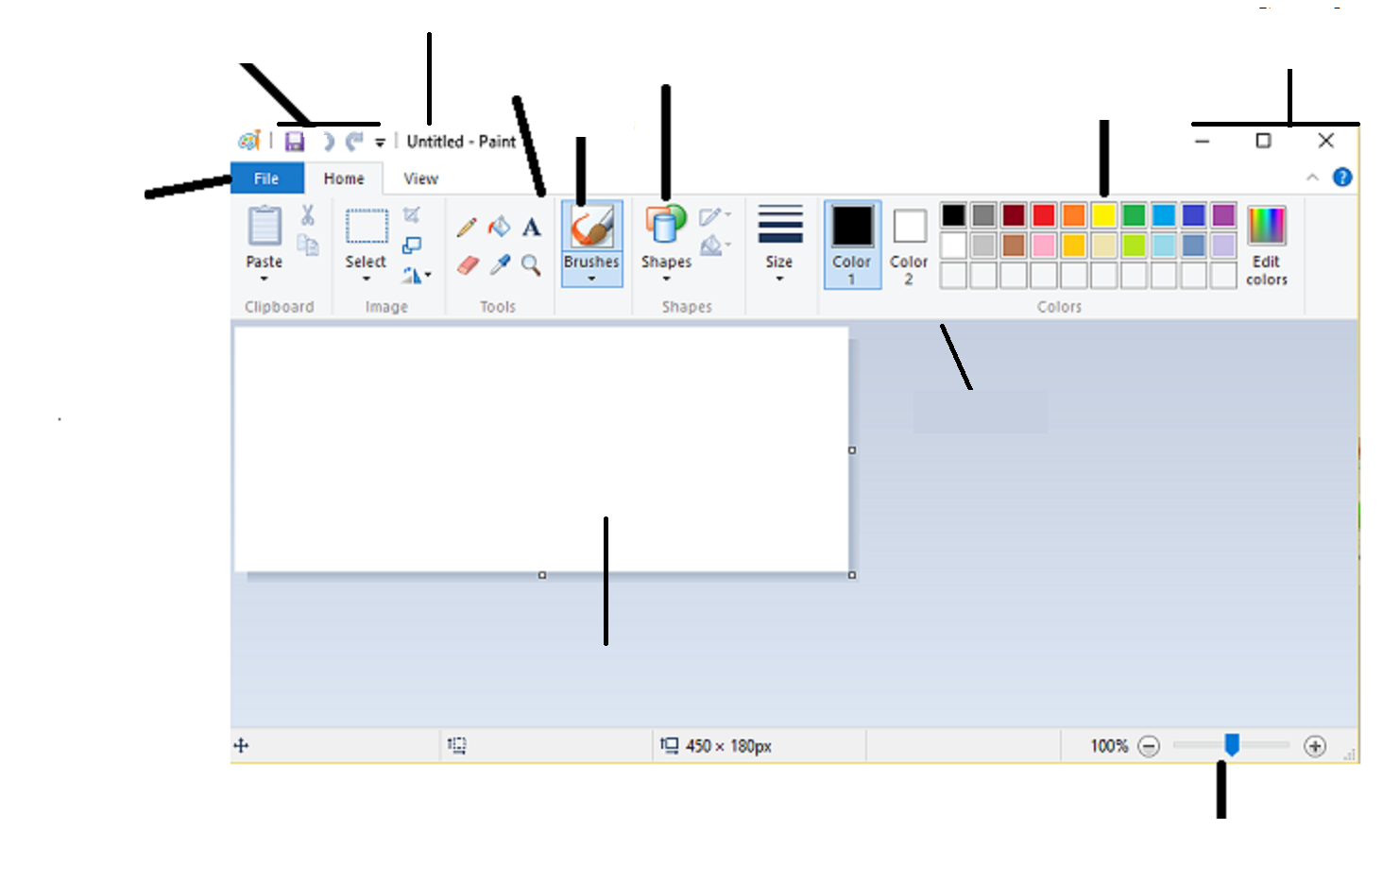

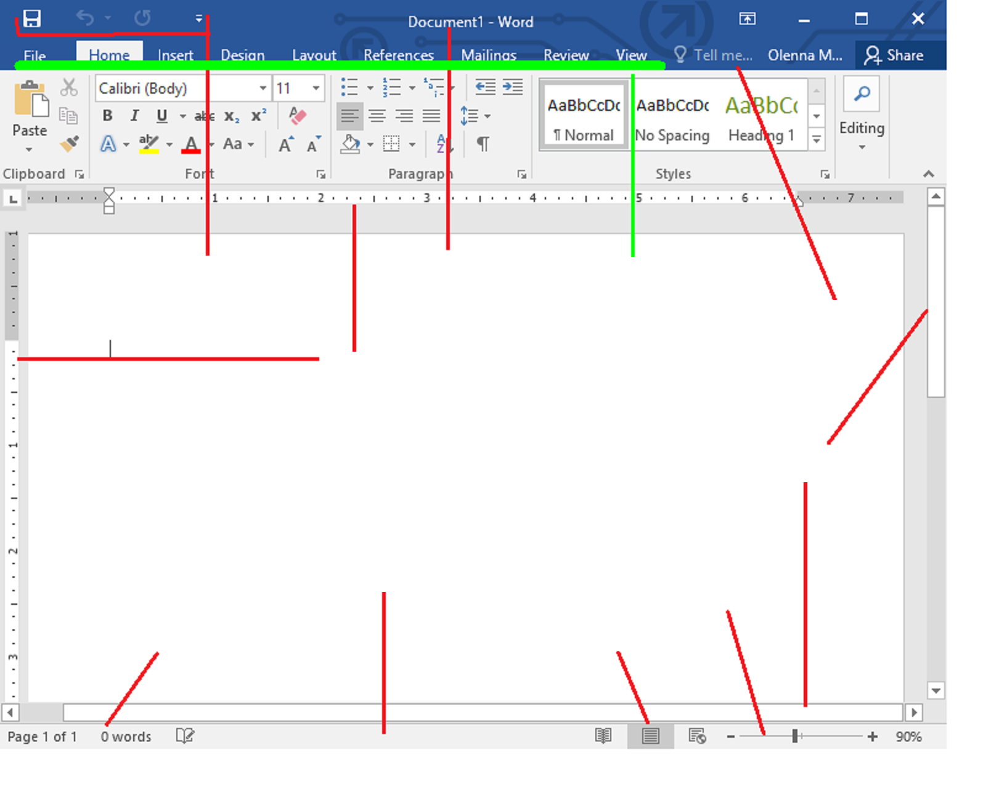



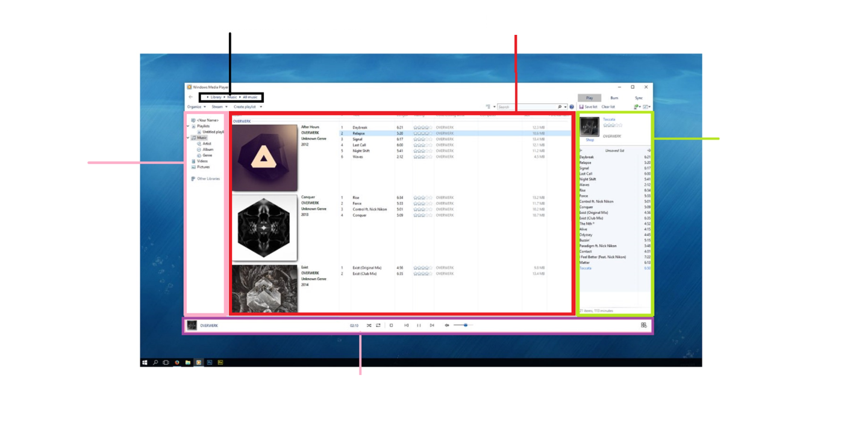

***Lab Activity 1***

*Design a flag for your school.*

* *Start by drawing a rectangle with the help of rectangle tool.*
* *Your flag must have atleast three different colors.*
* *Name of your school must be written on the flag.*

***Lab Activity 2***

*Design a new cartoon character. Be creative!*

* *Your character must use atleast three different shapes*
* *It must have atleast five different colors*
* *Write “Designed By” and your name somewhere near your drawing.*

***Lab Activity 3***

*Draw a tree.*

* *Select brown color from color palette and use thick brushes to draw stem and branches of the tree.*
* *Select green color and use airbrush to draw leaves.*

***Lab Activity 4***

*Draw face of your best friend.*

1. *Use brush tool for drawing the face*
2. *Use airbrush for drawing the hair*
3. *Be creative with your friend’s hairstyle!*
4. *Write your friend’s name in a colored font somewhere near your drawing.*

***Lab Activity 5***

*Design a picture that contains the following*

* *Any building (a house, a skyscraper, barn etc)*
* *A sky with clouds and a sun or a sky with stars and a moon*
* *Atleast two trees*
* *Atleast five flowers*
* *Other items may be added as you wish*

***Lab Activity 6***

* *Type your first name*
* *Copy and paste it 10 times*
* *Press Enter after each name*
* *Make the font size* of each name bigger than the previous one
* Each name should have a different color

**Lab Activity 7**

Make a banner for your school annual funfair

**Funfair**

**Please join us in the school ground**

**for annual funfair**

**Monday, October 15, 2018**

* Open a new document and save it as *Banner.*
* Select font *Rockwell,* font size 22, font color *red and Centre alignment.*
* Write ”Funfair” and press enter.
* Select font *Calibri,* font size 16, font color *black* andpress the button **B***.*
* Type “**Please join us in the school ground for annual funfair**”
* Type Enter.
* Select font color *blue*.
* Type “**Monday, October 15, 2018”.**
* Now click on *Insert* tab and select *Shapes* command from the *Illustrations* group.
* Look for the *banner* shape.
* Draw the shape over the text.
* Select the shape by double-clicking on it.
* Word will open the *Format* tab.
* Select *No Fill* option from the *Shape Fill command.*
* Use the small blue squares around the banner to adjust the size of shape.

**Lab Activity 8**

* Open a new document and save it as *Application.*
* Select font as *Times New Roman.*
* Type the following tex*t*
* *NOTE:* the main body of application should be “justified”

Sick Leave

To

The Principal,

Govt. Islamia High School,

Multan.

Sir,

I respectfully beg to state that I am sick and therefore unable to attend the school. Kindly grant me leave for **one day.** I shall be very thankful to you.

Yours Obediently,

*Shahzad Khan*

*Class 6th-A*

*Roll Number 15*

**Lab Activity 9**

* Change this line to your favorite color.
* Centralize this line.
* Italicize this line.
* Change this line to size 28.
* Make this line bold
* Change this line to capital letters.
* Underline this line.
* Change this line to Arial.
* Below this line, add a shape of your choice.
* Below this line, add your name using *green* color in Bold and underline it.

**Lab Activity 10**

* Type “I am a student of class 6”
* Copy and paste it 10 times and press Enter after each line.
* Choose a different *font color* and *font style* for each line.
* Write the name of font used in front of each line.